Bay lane road closure Diversions
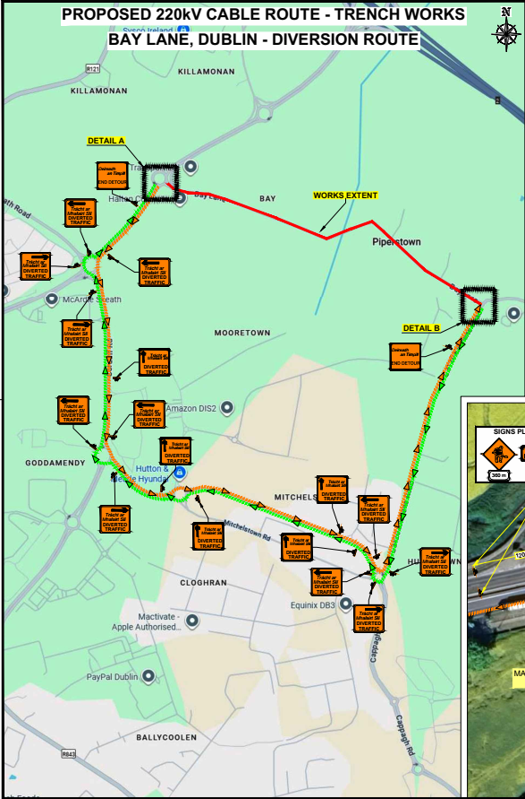
Road diversions are to be as per the below
- Diversion on the eastern side of Bay lane is southwards via L3120 Kilshane Road leading to Mitchelstown road. Westwards along Mitchelstown road towards Cruiserath road. Westwards along Cruiserath road towards Corduff Road. Northwards along Corduff Road until Roundabout with L3080 Ratoath and North west along Dual carriageway to Bay lane western access point. The above outlined route is highlighted in Green on the image attached. There will be allowance for local access on each side of Bay lane
- Diversion on the western side of Bay lane is South west along dual carriageway towards Cruiserath road. Eastwards along Cruiserath road towards Mitchelstown road. Eastwards along Mitchelstown road towards L3120 Kilshane road. Northwards along L3120 Kilshane road to the eastern side of Bay lane. The above outlined route is highlighted in orange on the image attached. There will be allowance for local access on each side of Bay Lane.

