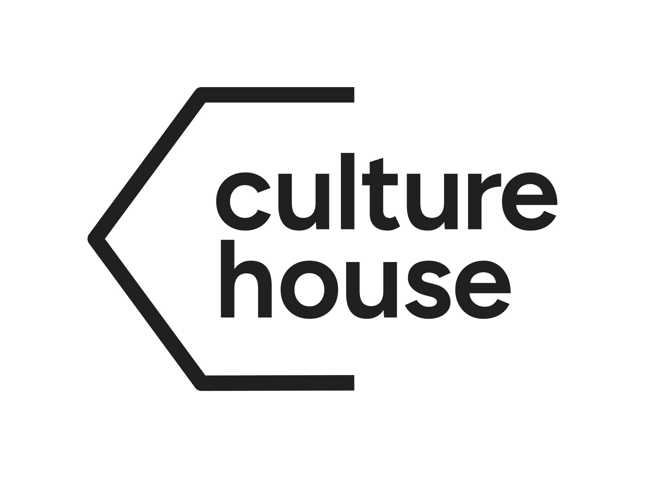
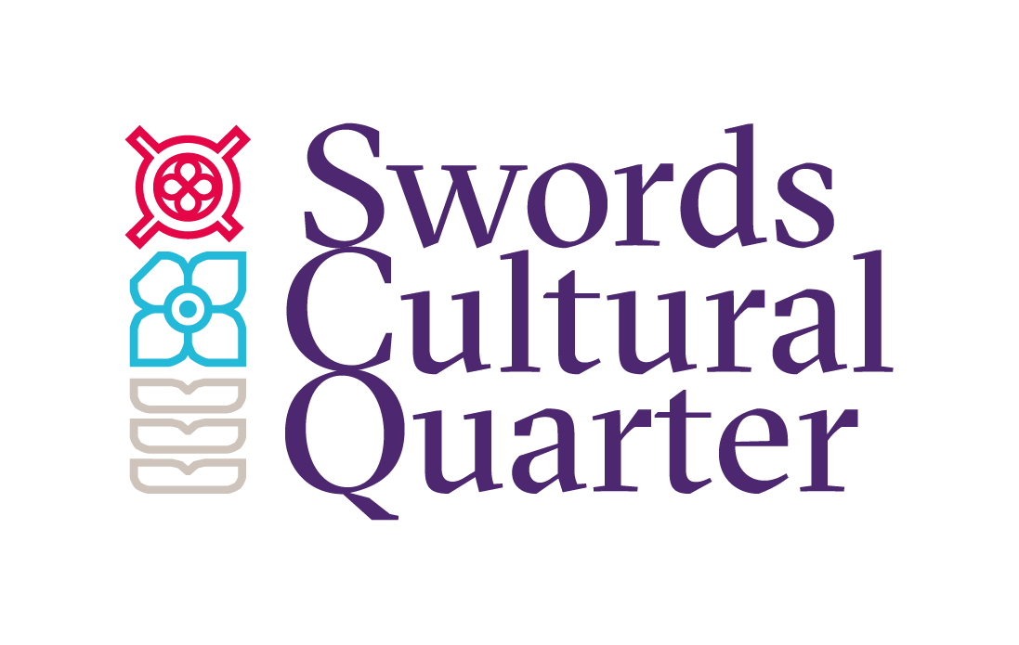
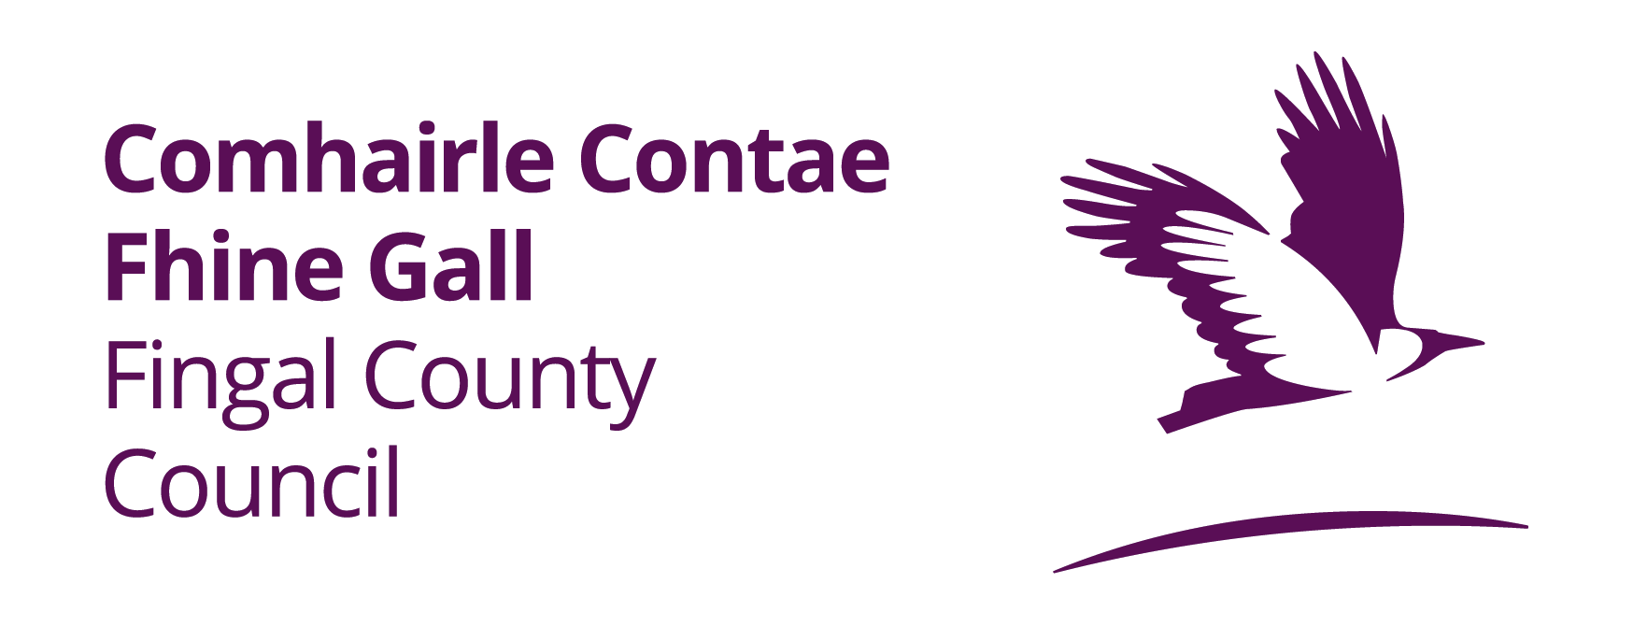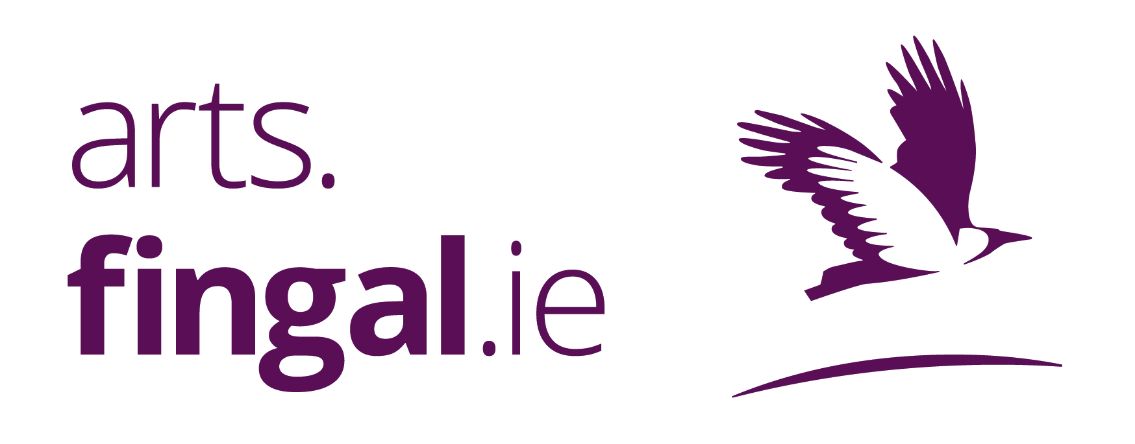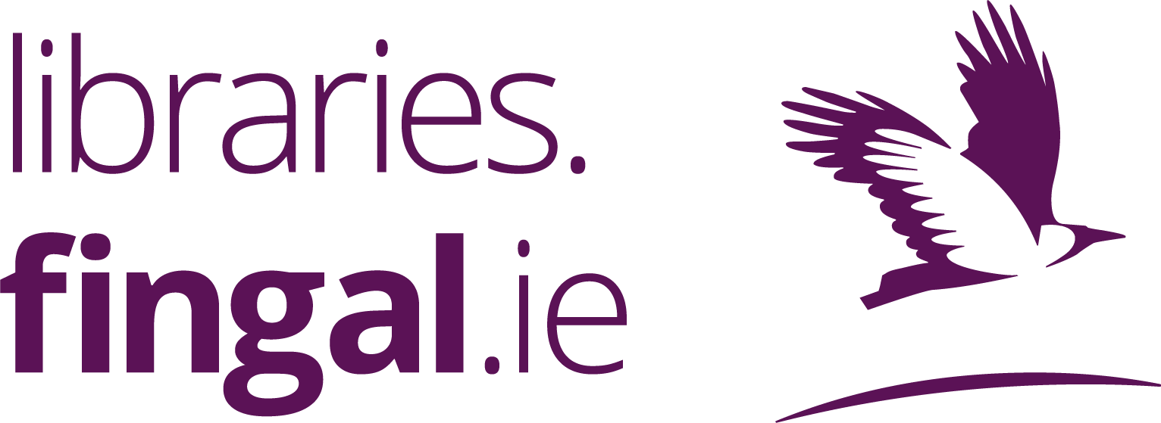

Swords Cultural Quarter Poet in Residence 2026–2027
A partnership between Fingal Arts Office and Fingal Libraries
Fingal Arts Office and Fingal Libraries invite applications for the Swords Cultural Quarter Poet in Residence 2026–2027.
This year-long residency will support a poet living in or from Fingal to become a creative connector across Arts, Libraries and communities in Swords during a significant period of cultural development.

About the Residency
This is not a studio-bound position, but a connective and outward-facing role. The selected poet will act as a cultural weaver—linking people, places, and ideas across Swords Cultural Quarter.
The poet will:
- Develop and present new creative work
- Connect artistic practice with public life
- Build meaningful relationships across libraries, arts spaces and community settings
- Lead audiences on a shared literary journey culminating in, and extending beyond, the launch of Culture House
The residency will help shape a shared cultural narrative across Swords at a moment of transition and growth.
The poet will be provided with dedicated desk space at The Carnegie, Swords for the duration of the residency.

The Carnegie
The Carnegie is a key cultural space within the evolving Swords Cultural Quarter. Originally a Carnegie Library, it has been reimagined as a centre for artistic innovation, learning and community engagement—retaining its founding ethos of access, knowledge and connection.
As Swords Cultural Quarter develops toward the opening of Culture House, the Poet in Residence will play a key role in:
- Reflecting the identity and imagination of the area
- Connecting past and future through language
- Building anticipation and participation around Culture House
- Continuing to activate cultural life beyond its opening
The Carnegie, library spaces, community venues and Culture House will be linked through the poet’s work as a shared creative thread.

What the Residency Offers
The selected poet will receive:
- Dedicated desk space at The Carnegie (12 months)
- Access to The Carnegie facilities for events and programming
- Access to Fingal Library spaces for readings, workshops and engagement
- Administrative, logistical and promotional support
- Curatorial support across Arts Office and Libraries programming
- Visibility through Arts Office and Library communication channels

Public Programme & Outputs
Over the course of the residency, the poet will deliver a public-facing programme that builds connection between communities and cultural spaces.
Public Readings (minimum 3)
- One flagship reading at The Carnegie
- At least two readings across Fingal library branches
- One event aligned with Culture House programming or milestone activity
Workshops & Community Engagement (minimum 6 sessions)
- Workshops across The Carnegie, libraries, schools and community settings
- At least one Poetry Clinic or mentoring session for emerging writers
- Participation in library-led initiatives (e.g. Poetry Day Ireland, youth or festival programming)
- Contribution to a reflective blog or creative response documenting the residency journey
- A written or poetic contribution linked to Culture House communications (format to be agreed)
Engagement Plan
Applicants will outline how they will engage communities, including:
- Target audiences and groups
- Methods and formats of engagement
- How activity builds toward Culture House
- Intended creative and community outcomes
End-of-Residency Showcase
The residency will conclude with a public event in Swords Cultural Quarter featuring:
- New work developed during the residency
- Reflections on community and partnership engagement
- Contributions from participants where appropriate
- A celebration of the shared cultural journey toward and beyond Culture House

Application Requirements
Applications should include:
- A brief outline of the writing project you will work on during the residency
- A current CV
- A brief statement of intent outlining why the residency appeals to you, and why it would be beneficial to your work
- A sample of current writing (8–10 pages or approximately 10–12 poems)

Selection Criteria
Applicants must:
- Be from or currently living in Fingal
- Be an emerging or established poet with evidence of publication and/or public readings
- Demonstrate experience in community or educational engagement
- Show capacity to work collaboratively across institutional settings
Applications should also demonstrate:
- Artistic vision for the residency
- A community and library engagement plan
- An approach to connecting Arts, Libraries and Culture House
- How the residency will support the applicant’s artistic development

Budget
- Artist stipend: €12,000
____________________________________________________________________________

Applications should be submitted to library.events@fingal.ie with the subject line “SCQ POET IN RESIDENCE 2026” no later than 5.00 p.m. June 5th, 2026.

