
















P R O P O S E D T R A F F I C M A N A G E M E N T S C H E M E

for

N O R T H

TMP 03

Sign Location Traffic Cones Event Route
LEGEND

TMP 02
Naul Vilage - R125 Swords Detour Naul Vilage - Oldtown - R125 Detour
Greenogue - Ashbourne - N2 - Meadesbrook Garristown - Ashbourne (Local Detour) Garristown - Pucky Lane (Local Detour) Direction of Traffic Flow
Traffic Management Operative

TMP 03

Detail A

Works TTM type: Static Type A

Design Type A: >12h

TMP 02

Detail A

Design Parameters:
- Minimum Sign Size mm
- Statutory Speed of the Road
LV-1 LV-1
(I) (III)
450 600
30km/h50
LV-1 LV-2 LV-2
(IV) (I) (II)
600 600 750
60 80 100

TMP 02
7. Lateral Safety Zone | 0.5m | 0.5m 0.5m 1.2m 1.2m
8. Leading Taper | 1in1m | 1in5m 1in10m 1in40 Lane-1in60  H/S-1in30
9. Maximum at Tapers Cone Space | 1m | 3m 3m 3m 3m
10. Maximum Longitudinal Cone Space | 3m | 3m 6m 12m 12m
11. Lane Width (m) | 2.5m | 3 (2.5) 3 (2.5) 3 m 3 m
12. Two-way Roadway width (m) | 5m | 5m 5m - -

TMP 03
- Distance between Advance Signs
- Number of Advance Signs
- Minimum Visibility of Signs
10m
1 (<12h)
2 (>12h)
25m
20m 2
50m
20m 120m 200m
3 (<12h) 3 (<12h) 3 (<12h)
2 (>12h) 4 (>12h) 4 (>12h)
60m 90m 120m

Detail B
Detail B
- Longitudinal Safety Zone
0.5m 5m
15m 45m
60m

TMP 03

Detail C
Note:
- All signs to comply with Chapter 8 of the "Traffic Signs Manual"-Guidance Document-2019.
- All Traffic Management to be carried out in accordance with Chapter 8 of the "Traffic Signs Manual".
- Detailed Risk Assessment to be carried out prior to the installation of Traffic Management System.
- Exact sign positions to be agreed on site.
- All affected Parties and An Garda Siochana to be notified prior to works commencing.
- Signs to be positioned so as not to cause an obstruction to other road users.
- All signs to be faced with retro-reflective material to class ref 2 of EN 12899.
- "End of Roadworks" sign placed 20m to 50m from end of works area.
- Road Closure points to be manned.

Event Location
Scale: N.T.S.

Rev: Description: Date: Job Details: Drawing: Dwg no:

Proposed Traffic Management Plan for Windmill Run, Garristown

TMP for Event Location 01
Rev:

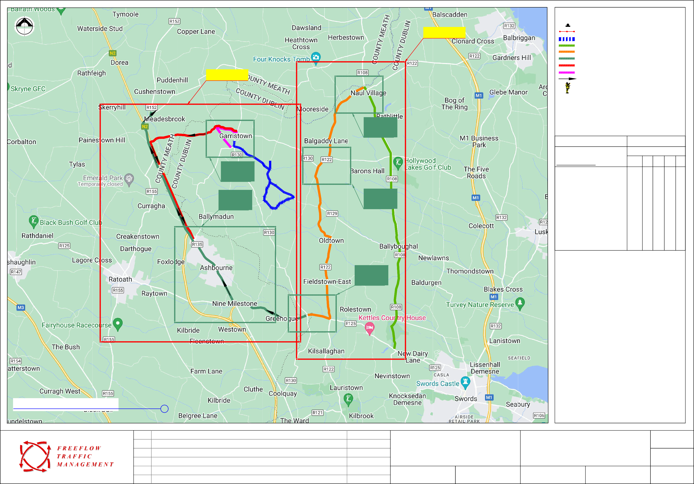
Sheet:
CAD File ref.:
Drawn By:
DM
Date:
January 2026
Scale:
As Shown

N O R T H

DETAIL A

50m

Sign Location Traffic Cones Event Route
LEGEND

Except for Access
Naul Vilage - R125 Swords Detour Naul Vilage - Oldtown - R125 Detour
Greenogue - Ashbourne - N2 - Meadesbrook Garristown - Ashbourne (Local Detour) Garristown - Pucky Lane (Local Detour) Direction of Traffic Flow
Traffic Management Operative

Except for Access

50m

50m
Works TTM type: Static Type A

Design Type A: >12h

Detail A

Design Parameters:
- Minimum Sign Size mm
- Statutory Speed of the Road
LV-1 LV-1
(I) (III)
450 600
30km/h50
LV-1 LV-2 LV-2
(IV) (I) (II)
600 600 750
60 80 100

DETAIL B
- Distance between Advance Signs
- Number of Advance Signs
- Minimum Visibility of Signs
10m
1 (<12h)
2 (>12h)
25m
20m 2
50m
20m 120m 200m
3 (<12h) 3 (<12h) 3 (<12h)
2 (>12h) 4 (>12h) 4 (>12h)
60m 90m 120m

- Longitudinal Safety Zone
0.5m 5m
15m 45m
60m

- Lateral Safety Zone
0.5m
0.5m 0.5m 1.2m 1.2m

- Leading Taper
1in1m
1in5m 1in10m
Lane-1in60 H/S-1in30

- Maximum at Tapers Cone Space 1m
1in40
- Maximum Longitudinal Cone Space 3m
3m 3m
3m 6m
3m 3m 12m 12m

- Lane Width (m)
2.5m
3 (2.5) 3 (2.5) 3 m 3 m

- Two-way Roadway width (m)
5m 5m
5m - -

TMP for Road Closures and Detours
Scale: N.T.S.

TMP 03

Detail B
Note:
- All signs to comply with Chapter 8 of the "Traffic Signs Manual"-Guidance Document-2019.
- All Traffic Management to be carried out in accordance with Chapter 8 of the "Traffic Signs Manual".
- Detailed Risk Assessment to be carried out prior to the installation of Traffic Management System.
- Exact sign positions to be agreed on site.
- All affected Parties and An Garda Siochana to be notified prior to works commencing.
- Signs to be positioned so as not to cause an obstruction to other road users.
- All signs to be faced with retro-reflective material to class ref 2 of EN 12899.
- "End of Roadworks" sign placed 20m to 50m from end of works area.
- Road Closure points to be manned.

Rev: Description: Date: Job Details: Drawing: Dwg no:

Proposed Traffic Management Plan for Windmill Run, Garristown

TMP for Road Closures and Detours 02
Rev:

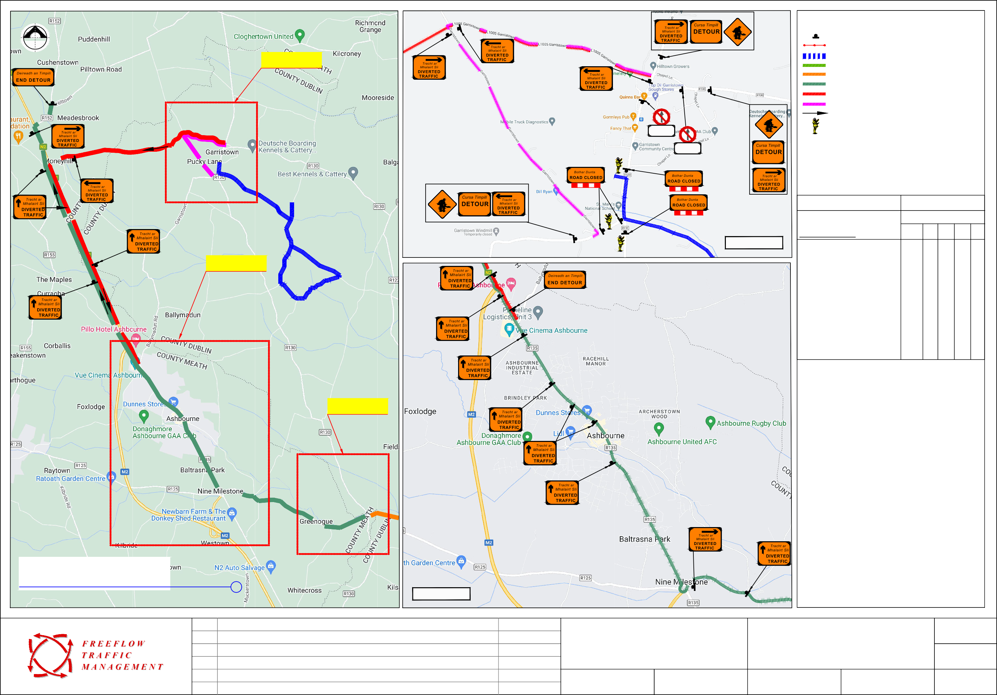
Sheet:
CAD File ref.:
Drawn By:
DM
Date:
January 2026
Scale:
As Shown

N O R T H

50m

Sign Location Traffic Cones Event Route
LEGEND

DETAIL A
Naul Vilage - R125 Swords Detour Naul Vilage - Oldtown - R125 Detour
Greenogue - Ashbourne - N2 - Meadesbrook Garristown - Ashbourne (Local Detour) Garristown - Pucky Lane (Local Detour) Direction of Traffic Flow
Traffic Management Operative

DETAIL B

Except for Access
50m

Detail A

Works TTM type: Static Type A

Design Type A: >12h

Except for Access
Except for Access

Design Parameters:
LV-1 (I)
LV-1 (III)
LV-1 LV-2 LV-2
- (I) (II)

  - Minimum Sign Size mm
  - Statutory Speed of the Road
450 600
30km/h50
600
60
600
80
750
100

100m
  - Distance between Advance Signs
  - Number of Advance Signs
  - Minimum Visibility of Signs
10m
1 (<12h)
2 (>12h)
25m
20m 2
50m
20m 120m 200m
3 (<12h) 3 (<12h) 3 (<12h)
2 (>12h) 4 (>12h) 4 (>12h)
60m 90m 120m

  - Longitudinal Safety Zone
0.5m 5m
15m 45m
60m

  - Lateral Safety Zone
0.5m
0.5m 0.5m 1.2m 1.2m

  - Leading Taper
1in1m
1in5m 1in10m
Lane-1in60 H/S-1in30

Except for Access
1in40
  - Maximum at Tapers Cone Space 1m
3m 3m
3m 3m

  - Maximum Longitudinal Cone Space 3m
3m 6m
12m 12m

Except for Access

Except for
  - Lane Width (m)
2.5m 3 (2.5) 3 (2.5) 3 m 3 m

Access
  - Two-way Roadway width (m)
5m 5m
5m - -

Except for Access

TMP for Road Closures and Detours
Scale: N.T.S.

DETAIL C

200m

100m

200m 100m

Except for Access

100m

Detail B

Detail C
Note:
- All signs to comply with Chapter 8 of the "Traffic Signs Manual"-Guidance Document-2019.
- All Traffic Management to be carried out in accordance with Chapter 8 of the "Traffic Signs Manual".
- Detailed Risk Assessment to be carried out prior to the installation of Traffic Management System.
- Exact sign positions to be agreed on site.
- All affected Parties and An Garda Siochana to be notified prior to works commencing.
- Signs to be positioned so as not to cause an obstruction to other road users.
- All signs to be faced with retro-reflective material to class ref 2 of EN 12899.
- "End of Roadworks" sign placed 20m to 50m from end of works area.
- Road Closure points to be manned.

Rev: Description: Date: Job Details: Drawing: Dwg no:

Proposed Traffic Management Plan for Windmill Run, Garristown

TMP for Road Closures and Detours 03
Rev:

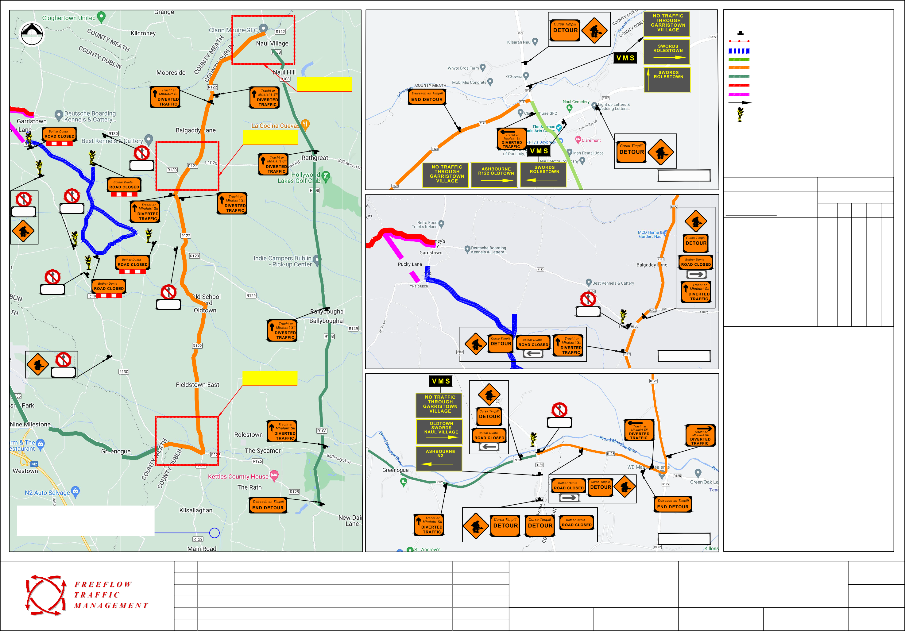
Sheet:
CAD File ref.:
Drawn By:
DM
Date:
January 2026
Scale:
As Shown

