
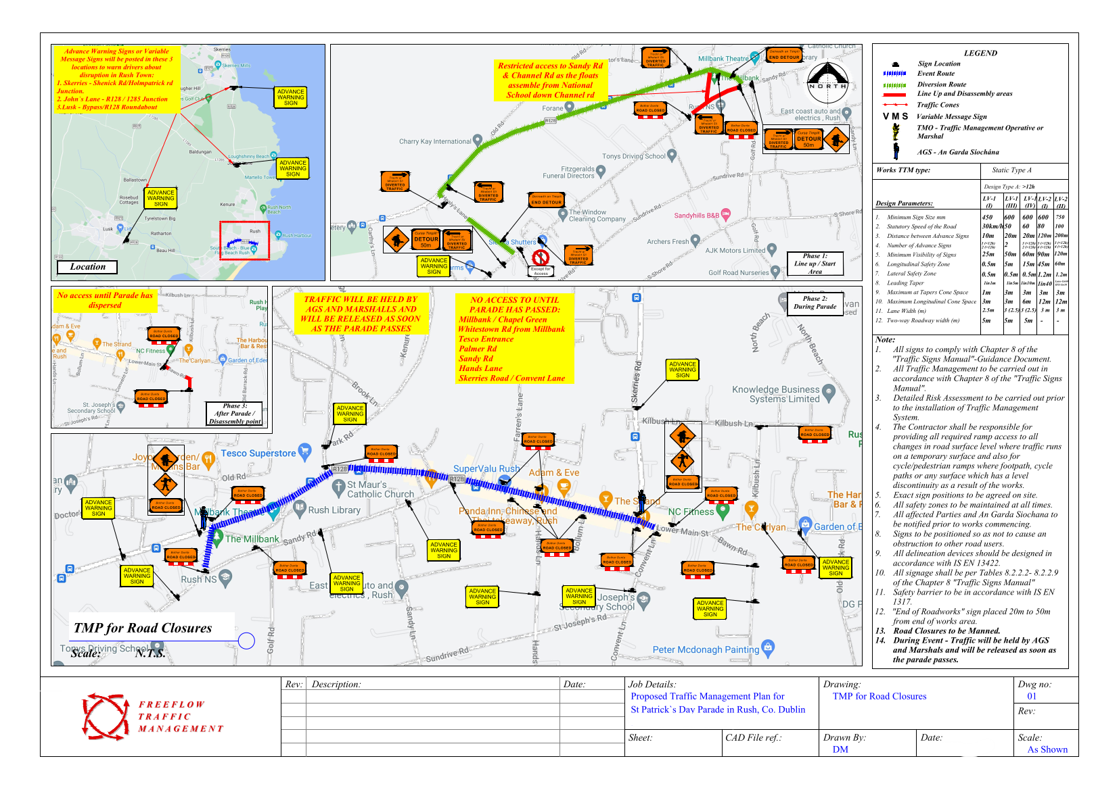
Tuesday 17th March 2026


P r o p o s e d T r a f f i c
M a n a g e m e n t S c h e m e

f o r
S t . P a t r i c k ' s D a y P a r a d e

in
R u s h , C o . D u b l i n

o n
Tuesday 1 7 t h M a r c h 2 0 2 6

