Balmoston Donabate,– Income Calculation Guide
2-Bedroom Houses
Property Type |  | No. Bed | Property storeys | Property Name | Market Value | Min. Purchase Price | Equity % | Max. Purchase Price | Gross Income
Mid-Terrace  Without Parking | 2-Bed |  | 2 Storey | The Maple | €425,000 | €320,000 | 24.71% | €403,750 | €90,844
Mid Terrace  With Parking | 2-Bed |  | 2 Storey | The Maple | €425,000 | €335,000 | 21.18% | €403,750 | €90,844

Balmoston Donabate Affordable Housing Scheme
Income Calculator based on a 2-Bed Mid Terrace House without Parking with Market Value of €425000
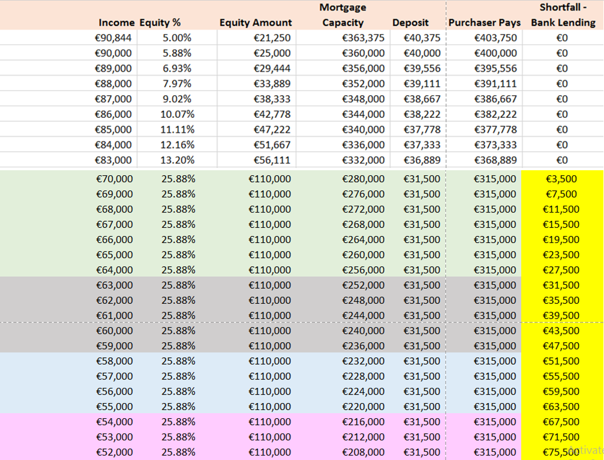
Baile na Móna, Swords, Affordable Housing Scheme
Income Calculator based on a 2-Bed End Terrace House with Parking with Market Value of €425,000
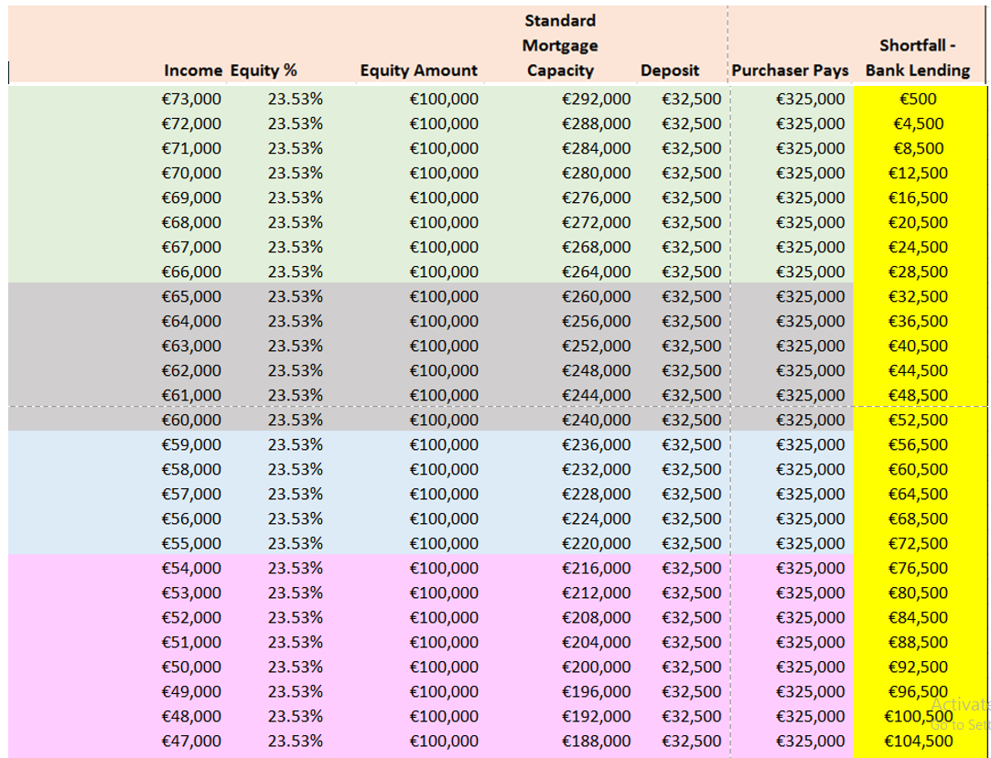
7Balmoston, Donabate– Income Calculation Guide
3-Bedroom Houses
Property Type | No. Bed | Property storeys | Property Name | Market Value | Min. Purchase Price | Equity % | Max. Purchase Price | Gross Income
Mid-Terrace  Without Parking | 3-Bed | 2 Storey | The Holly | €460,000 | €340,000 | 26.09% | €437,000 | €98,325
Mid Terrace  With Parking | 3-Bed | 2 Storey | The Holly | €460,000 | €355,000 | 22.83% | €437,000 | €98,325
End Terrace  Without Parking | 3-Bed | 2 Storey | The Cedar | €485,000 | €360,000 | 25.77% | €460,750 | €103,669
End Terrace  With Parking | 3-Bed | 2 Storey | The Cedar | €485,000 | €375,000 | 22.68% | €460,750 | €103,669

Balmoston Donabate, Affordable Housing Scheme
Income Calculator based on a 3-Bed Mid Terrace House without Parking with Market Value of €460,000
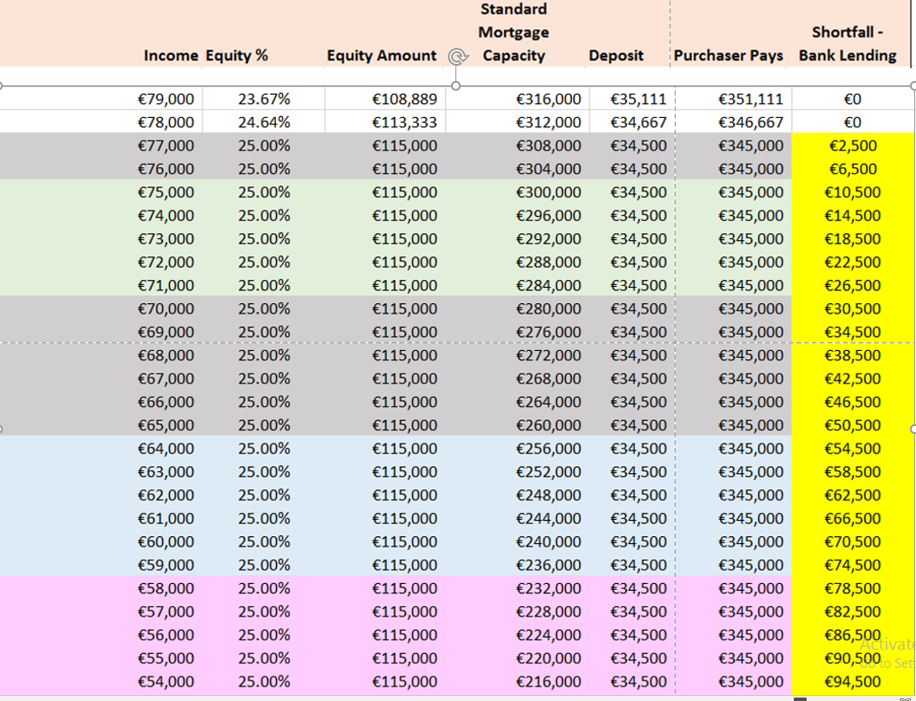
Balmoston, Donabate, Affordable Housing Scheme
Income Calculator based on a 3-Bed Mid Terrace House with Parking with Market Value of €460,000
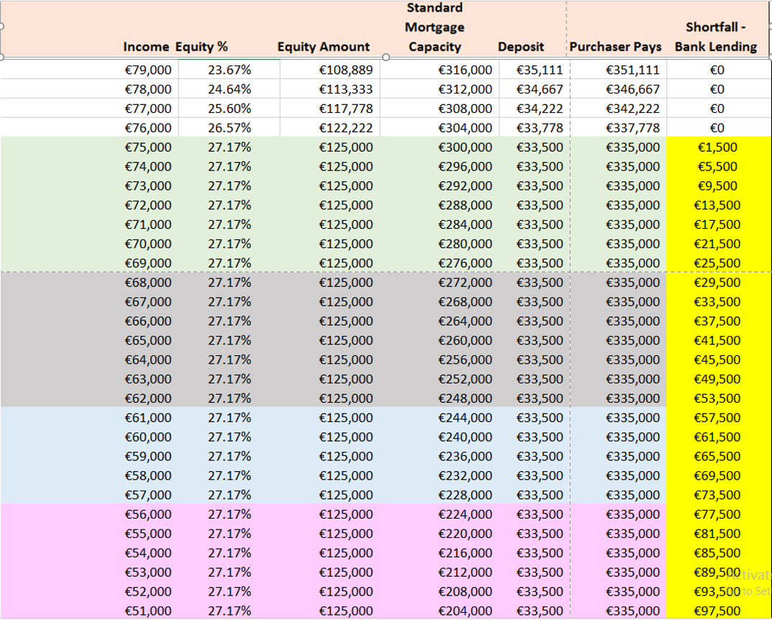

Balmoston Donabate, Affordable Housing Scheme
Income Calculator based on a 3-Bed End Terrace House without Parking with Market Value of €485,000
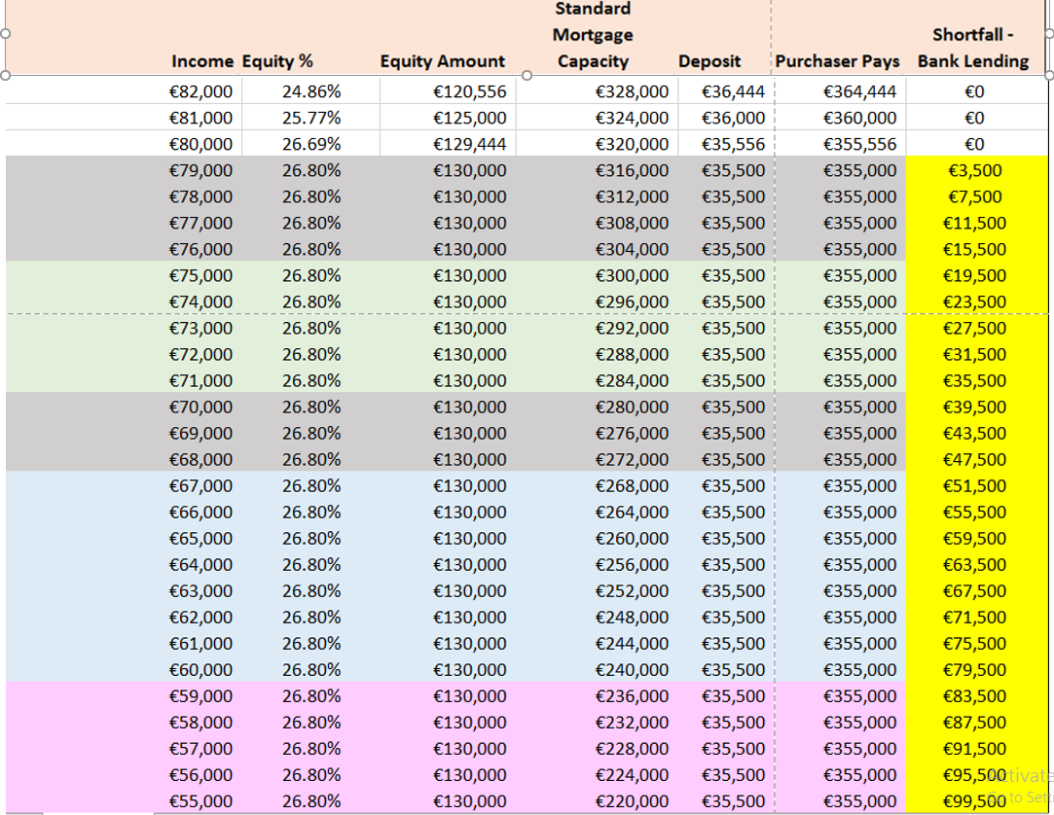

Balmoston Donabate, Affordable Housing Scheme
Income Calculator based on a 3-Bed End Terrace House with Parking with Market Value of €485,000
