**Balmoston Donabate,– Income Calculation Guide**

**2-Bedroom Houses**

|  |  |  |  |  |  |  |  |  |  |
| --- | --- | --- | --- | --- | --- | --- | --- | --- | --- |
| **Property Type** | | **No. Bed** | **Property storeys** | **Property Name** | **Market Value** | **Min. Purchase Price** | **Equity %** | **Max. Purchase Price** | **Gross Income** |
| **Mid-Terrace**  **Without Parking** | **2-Bed** | | 2 Storey | The Maple | €425,000 | **€315,000** | 25.88% | €403,750 | €90,844 |
| **Mid Terrace**  **With Parking** | **2-Bed** | | 2 Storey | The Maple | €425,000 | **€325,000** | 23.53% | €403,750 | €90,844 |

|  |
| --- |
| **Balmoston Donabate Affordable Housing Scheme** |
| Income Calculator based on a 2-Bed Mid Terrace House without Parking with Market Value of €425000 |

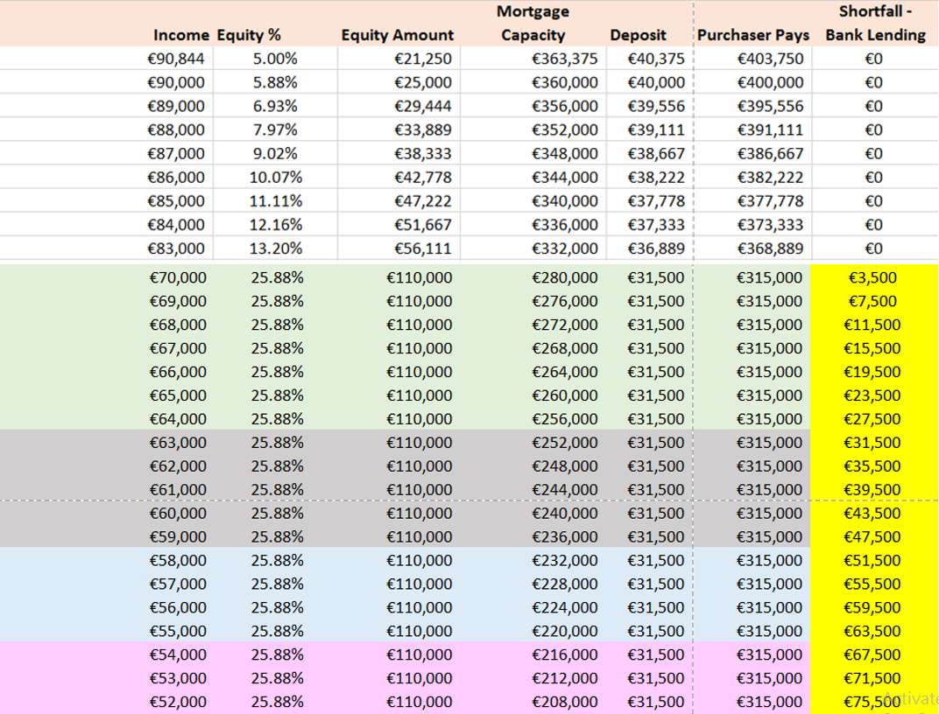

|  |
| --- |
| **Baile na Móna, Swords, Affordable Housing Scheme** |
| Income Calculator based on a 2-Bed End Terrace House with Parking with Market Value of €425,000 |

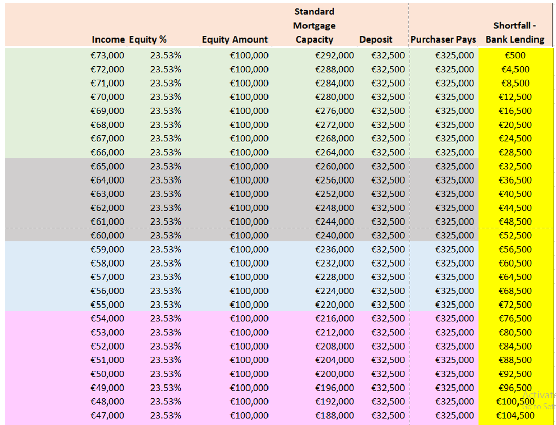

**7Balmoston, Donabate– Income Calculation Guide**

**3-Bedroom Houses**

|  |  |  |  |  |  |  |  |  |
| --- | --- | --- | --- | --- | --- | --- | --- | --- |
| **Property Type** | **No. Bed** | **Property storeys** | **Property Name** | **Market Value** | **Min. Purchase Price** | **Equity %** | **Max. Purchase Price** | **Gross Income** |
| **Mid-Terrace**  **Without Parking** | **3-Bed** | 2 Storey | The Holly | €460,000 | **€335,000** | 27.17% | €437,000 | €98,325 |
| **Mid Terrace**  **With Parking** | **3-Bed** | 2 Storey | The Holly | €460,000 | **€345,000** | 25.00% | €437,000 | €98,325 |
| **End Terrace**  **Without Parking** | **3-Bed** | 2 Storey | The Cedar | €485,000 | **€355,000** | 26.8% | €460,750 | €103,669 |
| **End Terrace**  **With Parking** | **3-Bed** | 2 Storey | The Cedar | €485,000 | **€390,000** | 24.7% | €460,750 | €103,669 |

|  |
| --- |
| **Balmoston Donabate, Affordable Housing Scheme** |
| Income Calculator based on a 3-Bed Mid Terrace House without Parking with Market Value of €460,000 |

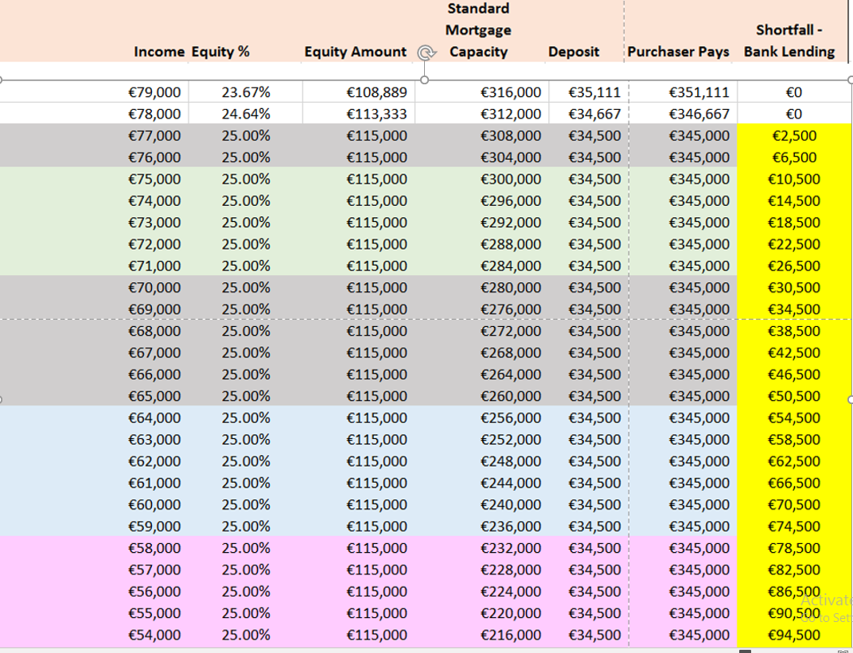

|  |
| --- |
| **Balmoston, Donabate, Affordable Housing Scheme** |
| Income Calculator based on a 3-Bed Mid Terrace House with Parking with Market Value of €460,000 |

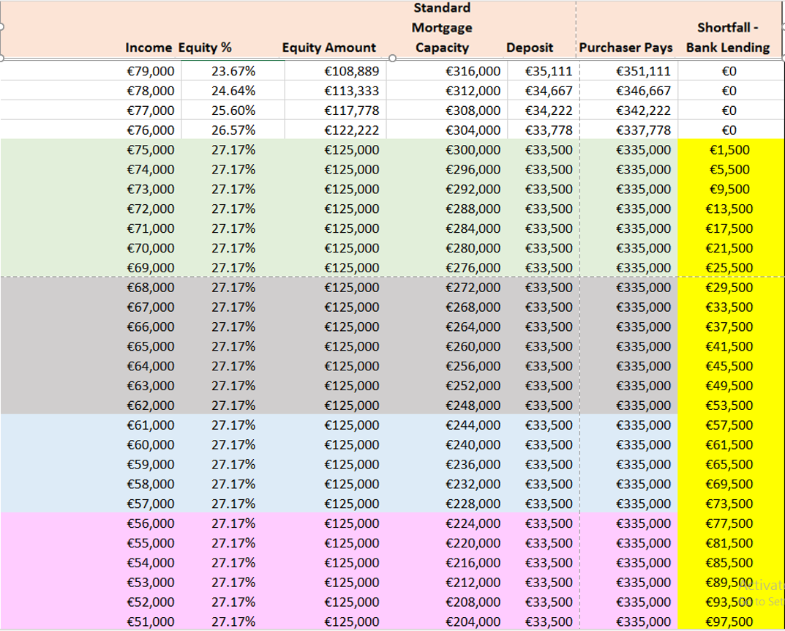

|  |
| --- |
| **Balmoston Donabate, Affordable Housing Scheme** |
| Income Calculator based on a 3-Bed End Terrace House without Parking with Market Value of €485,000 |

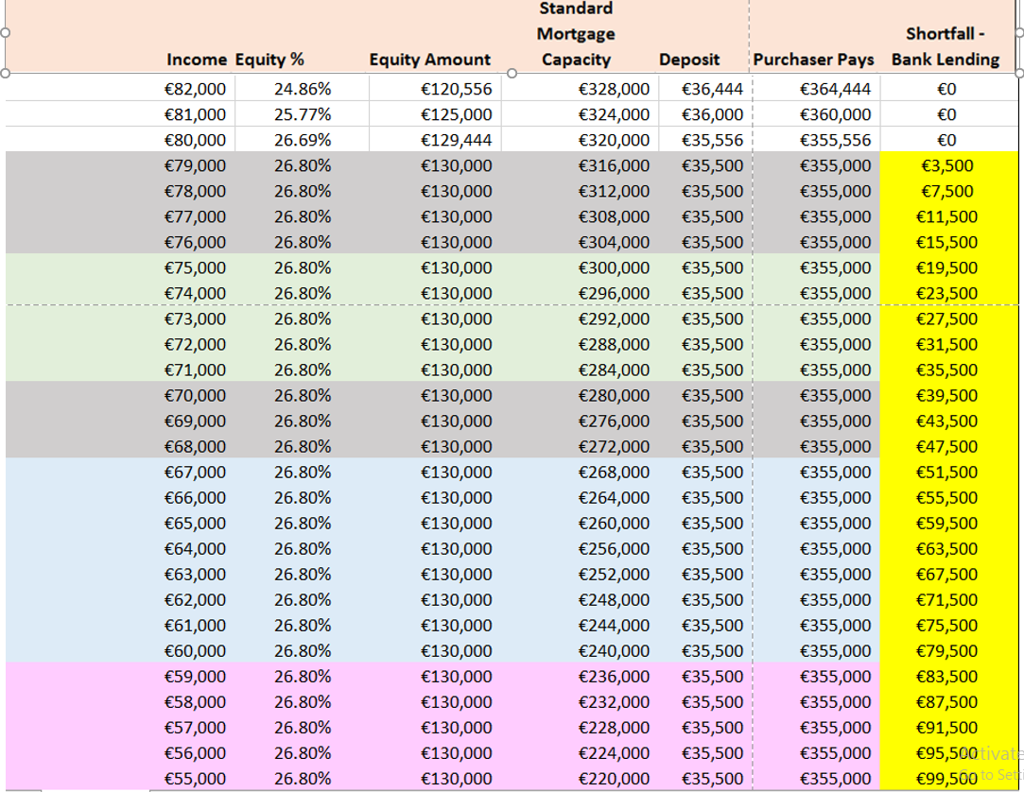

|  |
| --- |
| **Balmoston Donabate, Affordable Housing Scheme** |
| Income Calculator based on a 3-Bed End Terrace House with Parking with Market Value of €485,000 |

