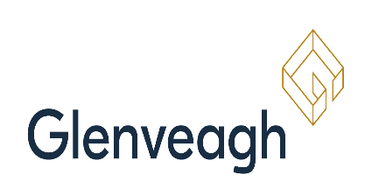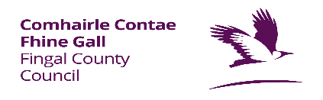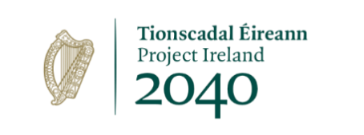

Affordable Housing at Balmoston, Donabate
  - Frequently Asked Questions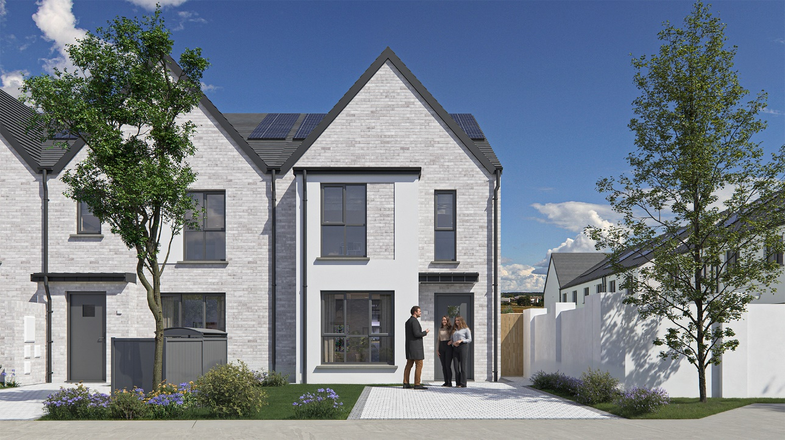

Table Of Contents
1. Where are the Affordable Homes located? 2
2. What type of properties are available and how much will they cost? 2
3. How does the Affordable Housing Scheme work? 3
4. Am I eligible for this scheme? 3
5. How do I prove my right to reside indefinitely in the State? 4
6. How is purchasing power calculated? 5
7. How will successful applicants be determined? 5
8. Am I eligible to apply if I am not a first-time buyer? 5
9. How do I apply for the scheme? 6
10. Do I need to be approved for a Mortgage in order to apply? 7
11. What documentation is needed to support my application? 7
12. What file types will be accepted on the application portal? 11
13. When will the properties be available? 11
14. How much deposit do I need? 11
15. Stamp Duty 12
16. How do I know which property to apply for? 12
17. What is the market value of the properties? 12
18. How is the affordable purchase price calculated? 13
19. How is a decision made on my application? 19
20. What is the Scheme of Priority? 19
21. If I am successful, will I be able to choose which property I want? 20
22. What is the Affordable Dwelling Contribution? 21
23. What is the Affordable Dwelling Equity Share? 21
24. What is a Redemption Payment? 21
25. Can I rent out the property? 21
26. What is an Affordable Dwelling Purchase Agreement? 22

1. Where are the Affordable Homes located?
Fingal County Council is partnering with Glenveagh Homes to provide 73 new homes for sale under the Affordable Housing Scheme. The homes are located in Balmoston, Donabate and will be offered for sale to eligible purchasers nominated by Fingal County Council’s Affordable Housing Team. Please visit fingal.ie/AffordableHousing/xxx, affordablehomes.ie, https://glenveagh.ie/developments/xxx or download the Balmoston , https://glenveagh.ie/developments/xxx or download the Balmoston 2 brochure for more information.

2. What type of properties are available and how much will they cost?
The scheme will consist of 53 2-bedroom houses and 98 3-bedroom houses.
Property Type | Number of Homes | Floor Area | Open Market Value | Minimum Sale Price | Approximate % Reduction from Market Value | Maximum Sale Price
2 Bed Mid Terrace (with Parking) | 14 | 87 sqm | €425,000 | €320,000 | 24.71% | €403,750
2 Bed Mid Terrace (No Parking) | 15 | 87 sqm | €425,000 | €335,000 | 21.18% | €403,750
3 bed Mid Terrace (with Parking) | 23 | 107 sqm | €460,000 | €340,000 | 26.09% | €437,000
3 Bed Mid Terrace (no Parking) | 1 | 107 sqm | €460,000 | €355,000 | 22.83% | €437,000
3 Bed End Terrace (with Parking) | 19 | 105 sqm - 106 sqm | €485,000 | €360,000 | 25.77% | €460,750
3 Bed End Terrace (no Parking | 1 | 105 sqm - 106 sqm | €485,000 | €375,000 | 22.68% | €460,750

3. How does the Affordable Housing Scheme work?
Through the Affordable Housing Scheme, the Council makes a contribution towards the cost of your new home in exchange for an equity share in it. The Council may provide between 5% and 40% of the cost of your home, in return for the same percentage of equity. The specific percentage equity available will differ per development. The percentage equity available for Balmoston, Donabate is between (5% and 25.00%). You can “buy out” the Council’s share at any stage, but you must do so within 40 years.
To participate in the scheme, applicants will be required to maximise their mortgage capacity, which is usually calculated based on 4 times a household income. A mortgage must be obtained from a participating lender* or Local Authority Home Loan. *Participating lenders are AIB (including EBS & Haven), Bank of Ireland, Permanent TSB, Avant Money, Community Credit Union Limited & Aviate Credit Union –

4. Am I eligible for this scheme?
In order to be eligible to apply for the scheme at Balmoston, Donabate
, you must satisfy the below criteria;
- Be over 18 years of age.
- Be a first-time buyer or meet the exceptions under the Fresh Start Principle.
- Your purchasing power must not be more than 95% of the market value of the home.
- To be eligible for a 2-bedroom mid terrace house- with Parking, your gross household income for the last 12 months should not exceed €90,844
- To be eligible for a 2-bedroom mid- terrace house (without parking), your gross household income for the last 12 months should not exceed €90,844
- To be eligible for a 3-bedroom mid terrace house (with parking), your gross household income for the last 12 months should not exceed €98,325
- To be eligible for a 3-bedroom mid terrace house (without parking), your gross household income for the last 12 months should not exceed €98,325
- To be eligible for a 3-bedroom end terrace house (with parking), your gross household income for the last 12 months should not exceed €103,669
- To be eligible for a 3-bedroom end terrace house (without parking), your gross household income for the last 12 months should not exceed €103,669
- Each person included in the application must have the right to reside indefinitely in the State. All non-EEA/EU applicants must be legally resident in Ireland for a period of 5 years; or have leave to remain extending to potentially permit 5 years reckonable residence; or have indefinite leave to remain in the State.
- The affordable home must remain as your normal place of residence, i.e. where you live.
Further information on income that is assessable, including rules around overtime, bonuses and commission, can be viewed here in the Income Assessment Policy Document.

5. How do I prove my right to reside indefinitely in the State?
- For non-EU/EEA applicants, please submit a copy of your valid Irish Resident Permit (IRP) indicating which stamp/permission type you have (e.g. Stamp 4, Stamp 1G).
- UK citizens will be regarded as being legally resident in Ireland. (This accords with the Common Travel Area requirements).

6. How is purchasing power calculated?
The purchasing power of applicants will be calculated as the combined total of:
- Maximum mortgage capacity (normally 4 times gross household income) plus,
- 10% deposit, plus,
- Relevant savings.*
- Help to buy (www.revenue.ie)
*Where the applicant has excess savings or money in excess of the 10% deposit plus an additional €30,000.

7. How will successful applicants be determined?
As well as the above eligibility criteria, a Scheme of Priority for households deemed eligible will apply to the scheme in the instance where there are more applicants than properties available.
The Scheme of Priority can be viewed on our website here.
The Scheme of Priority states:
- Applications who meet all of the eligibility criteria will be prioritised by time and date submitted, i.e. first come first served.
- Applications with a household of 2 or more people will be prioritised for a 3-bedroom house.

8. Am I eligible to apply if I am not a first-time buyer?
Yes. Certain exemptions will apply under the Fresh Start Principle, including:
- Applicant(s) that previously held a legal interest in a residential property but is divested of this legal interest through any of the following mechanisms may be eligible to apply:
  - Legal Separation
  - Divorce
  - Bankruptcy
  - Insolvency

- Applicant(s) that previously owned, was beneficially entitled to, or have had an interest in a dwelling in the state and that this dwelling, because of its size, is not suited to the current accommodation needs of the applicant’s household i.e., an overcrowded house, may be eligible to apply.
**Please note: If applying as a joint application, both applicants do not need to have the same Buyer Status. One applicant can be a first-time buyer and the other can qualify under the Fresh Start Principle, however both must also meet all the other eligibility criteria.

9. How do I apply for the scheme?
The application process will be via an online portal. The link to the online portal is available on our website here. The application portal for Balmoston, Donabate will open on Wednesday 5th of November at 12 p.m. and will close on Wednesday 26th November at 5 p.m.
In the online application process, applicants will have to:
- provide personal details (e.g., name, address, date of birth, PPSN),
- confirm and provide proof that they are a First-Time Buyer or that they qualify under the Fresh Start Principle,
- declare the total gross annual income for their household for the last 12 months,
- provide evidence of their 10% deposit and any savings, i.e., bank statements,
- provide evidence of how they intend to Finance the property in the form of a mortgage approval-in-principle.
- prove that they have the right to reside indefinitely in the State.
The supporting documentation that will be required, can be viewed here. Your submission will ONLY be awarded a date and timestamp when you submit a COMPLETE application. All application details and data submitted will only be retained for this scheme and will not be carried forward for any future affordable housing scheme(s).
Applicants who submit multiple applications and/or include any false or misleading information on their application will be disqualified from this process.
Click here to view to an online tutorial for the online application https://www.youtube.com/watch?v=9_Rqpx2J09E

10. Do I need to be approved for a Mortgage in order to apply?

Applicants are strongly advised to submit a Mortgage Approval in Principle letter from their proposed lender confirming the maximum mortgage available to them. Applicants can use a mortgage from any approved private lending institution, such as Bank of Ireland, Permanent TSB, AIB (including EBS & Haven), Avant Money, Community Credit Union and Aviate Credit Union.
Alternatively, finance can be sourced via Fingal County Council by way of a Local Authority Home Loan. Please visit https://www.fingal.ie/localauthorityhomeloan for more details.

11. What documentation is needed to support my application?

- Proof of Income Documentation required:

- If EMPLOYED, please provide your most recent Employment Detail Summary (previously known as P60) which is available via www.revenue.ie/MyAccount.

AND

Please also arrange to have this salary certificate completed by your employer. Payslips are NOT acceptable evidence.

- If SELF EMPLOYED, please upload Accountants Report/Audited Accounts (2 Years Required), Current Tax Balancing Statement & Current Preliminary Revenue Tax Payment Receipt.

- If NOT EMPLOYED, please upload Statement of total benefits received from Social Welfare which can be requested via email from your local Social Welfare/Intreo office.

- Proof of Citizenship:

- Passport or Birth Certificate

*In the event you upload a Birth Certificate as proof, you must also upload photographic ID such as valid passport, EU Identity Card, EU/EEA Driving Licence.

- Proof of the Right to Reside in Ireland (if applicable):

For non-EU/EEA applicants:
- please submit a copy of your Irish Resident Permit (IRP) card, indicating which stamp/permissions you have, e.g. Stamp 4, Stamp 1G.
- All non-EEA/EU applicants who do not have a Stamp 4 must be legally resident in Ireland for a period of 5 years; or have leave to remain extending to potentially permit 5 years reckonable residence; or have indefinite leave to remain in the State. Five years proof of address and IRP cards must be submitted.
- An application from a non-EEA/EU national, who is a spouse or civil partner of an EU/EEA national, may be considered as part of a joint application for that household, provided they have a valid residence card or permanent residence card with a valid Stamp 4EUFam.
- UK citizens will be regarded as being legally resident in Ireland. (This accords with the Common Travel Area requirements).

- Evidence of Ability to Finance the Purchase:

- A mortgage letter of approval in principle from a participating lender stating the maximum mortgage available to applicants,

and

- Proof of savings and deposit in the form of a current bank statement on headed paper dated within the last 6 months. (If applicable, please include proof of Help-to-Buy).

- Proof of Buyer Status:

For First Time Buyers –

- Confirmation of eligibility for Help to Buy Scheme: Printout from Revenue portal (myAccount for PAYE applicants / ROS for Self-assessed applicants) confirming names of applicant(s) and maximum entitlement under the scheme), OR a printout from Revenue portal showing application submitted/acknowledged and “Under Review”. If submitting a joint application, the HTB application must also be in joint names.

*Note that applicants are considered first-time-buyers only if BOTH are buying their home for the first time.

Further information on Help to Buy is available on Revenue.ie.

- If you are a First Time Buyer and not availing of the Help to Buy, please provide a sworn affidavit from a Solicitor confirming that you have never previously owned a dwelling in Ireland or any other State.

For Fresh Start Applicants –

- Court Decree / Separation Agreement / Solicitors letter confirming the applicant is divorced/separated or otherwise and have left the property and divested themselves of their interest in the property.
- Copy of Land Registry showing name removed from property.
- Where the applicant has been divested of a previous property through insolvency or bankruptcy proceedings, proof of the applicant’s status on the bankruptcy register is required. Proof that any property you previously owned or built has been sold, or given as part of a personal insolvency, bankruptcy agreement or other legal insolvency process.
- Applicant who’s dwelling because of its size, is not suited to the current needs of their household, please provide an up-to-date valuation of your current property. Your current property must be sale agreed or advertised for sale.

- Proof of Residency in Fingal Administrative area for a minimum of 5 years, for applicants to qualify under the 30% Residency Rule (provide at least one document dated in each of the 5 years)

- Series of utility bills
- Bank/Credit Union statements *see note below.
- Documents issued by any government department that shows your address.

**Please note, if the ‘Date of Statement’ is ‘forward’ as circled below, the document will not count as part of your proof of residency. This part of the document should include an actual date in order to be valid, for example: 3 June 2021.

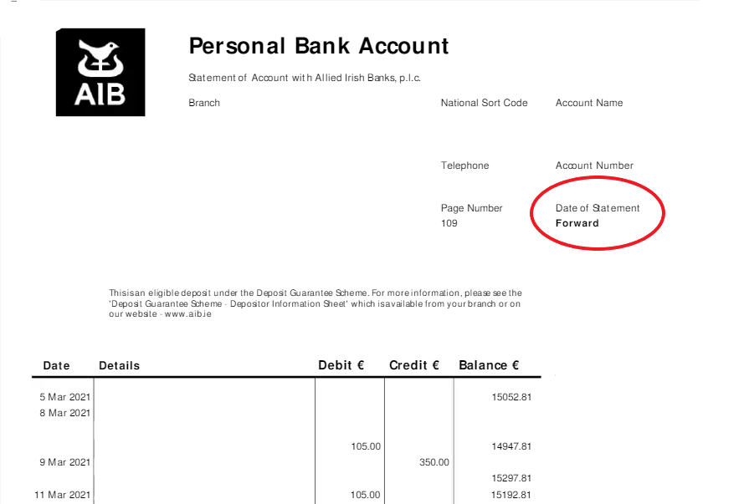

12. What file types will be accepted on the application portal?

The portal will accept the following image files:
- PDF,
- JPEG,
- PNG.
Editable documents such as Word (.doc), or Excel (.xls) are not accepted.

13. When will the properties be available?

The properties are expected to be completed on a phased basis, starting from Q4 ‘26 / Q1 ‘27

14. How much deposit do I need?

The developer requires a €3,000 booking deposit which is fully refundable up until signing of contract. A further deposit is then required on exchanging of contracts. Financial institutions require that a minimum 10% deposit must be raised by purchasers.
Example:
For a property with a purchase price of €315,000 you will need a deposit of at least €31,500

15. Stamp Duty

Stamp Duty is calculated on the full Market Value of the house and is payable by the applicant.

16. How do I know which property to apply for?

The property you apply for must be within your affordability and must also suit your household’s needs in line with the Scheme of Priority.

The Scheme of Priority states:
- When a scheme is oversubscribed, applications with a household of 2 or more people will be prioritised for a 3-bedroom house.
This means that if you are a single applicant with no other household members, your application will not be prioritised for a 3-bedroom house if the scheme is oversubscribed. You can apply for both property types if you wish, but this will require making two separate applications.
Full information can be found in the Scheme of Priority, which can be viewed by clicking here.

17. What is the market value of the properties?

The market value of an affordable home is the price for which the affordable home might reasonably be expected to achieve on the open market. The market value of the properties in Balmoston, Donabate are below:

- 2 Bed Mid Terrace - €425,000
- 3 Bed Mid Terrace - €460,000
- 3 Bed End Terrace - €485,000

18. How is the affordable purchase price calculated?
Fingal County Council, in line with the Affordable Housing Regulations, will set a minimum price that the affordable properties can be sold for. The affordable purchase price to be paid by an applicant will all depend on that applicant’s purchasing power and their ability to raise the relevant finances.

Worked Example for a 2-Bedroom Mid Terrace House without Parking in Balmoston, Donabate
The below example shows different incomes and how they determine the affordable purchase price and the Council’s equity share of a property with a market value of €425,000
Open Market  Value | Minimum Price | Income | Equity % | Equity  Amount | Standard  Mortgage | Deposit | Shortfall - Savings,HTB  Gifts | Purchaser  Pays
€425,000 | €315,000 | €70,000 | 25.88% | €110,000 | €280,000 | €31,500 | €3,500 | €315,000
€425,000 | €315,000 | €63,000 | 25.88% | €110,000 | €252,000 | €31,500 | €31,500 | €315,000
€425,000 | €315,000 | €48,000 | 25.88% | €110,000 | €192,000 | €36,000 | €91,500 | €315,000

Worked Example for a 2-Bed Mid Terrace House with Parking in Balmoston, Donabate
The below example shows two different incomes and how they determine the affordable purchase price and the Council’s equity share of a property with a market value of €425,000
Open Market  Value | Minimum Price | Income | Equity % | Equity  Amount | Standard  Mortgage | Deposit | Shortfall - Savings, HTB  Gifts | Purchaser  Pays
€425,000 | €325,000 | €69,000 | 25.53% | €100,000 | €276,000 | €32,500 | €16,500 | €325,000
€425,000 | €325,000 | €61,000 | 25.53% | €100,000 | €244,000 | €32,500 | €48,500 | €325,000
€425,000 | €325,000 | €54,000 | 25.53% | €100,000 | €216,000 | €32,500 | €76,500 | €325,000

Worked Example for a 3-Bed Mid Terrace House without parking in Balmoston, Donabate
The below example shows different incomes and how they determine the affordable purchase price and the Council’s equity share of a property with a market value of €460,000.
Open Market  Value | Minimum Price | Income | Equity % | Equity  Amount | Standard  Mortgage | Deposit | Shortfall - Savings, HTB  Gifts | Purchaser  Pays
€460,000 | €335,000 | €98,325 | 7.22% | €33,200 | €393,300 | €33,500 | €0 | €335,000
€460,000 | €335,000 | €76,000 | 26.63% | €122,500 | €304,000 | €33,500 | €0 | €335,000
€460,000 | €335,000 | €60,000 | 27.17% | €125,000 | €240,000 | €33,500 | €61,500 | €335,000
Worked Example for a 3-Bed Mid Terrace House with parking in Balmoston, Donabate
The below example shows different incomes and how they determine the affordable purchase price and the Council’s equity share of a property with a market value of €460,000.
Open Market  Value | Minimum Price | Income | Equity % | Equity  Amount | Standard  Mortgage | Deposit | Shortfall - Savings, HTB  Gifts | Purchaser  Pays
€460,000 | €345,000 | €98,300 | 7.02% | €32,300 | €393,200 | €34,500 | €0 | €345,000
€460,000 | €345,000 | €74,500 | 25.00% | €115,000 | €298,000 | €34,500 | €12,500 | €345,000
€460,000 | €345,000 | €55,000 | 25.00% | €115,000 | €220,000 | €34,500 | €90,500 | €345,000

Worked Example for a 3-Bed End Terrace without Parking in Balmoston, Donabate
The below example shows different incomes and how they determine the affordable purchase price and the Council’s equity share of a property with a market value of €485,000
Open Market  Value | Minimum Price | Income | Equity % | Equity  Amount | Standard  Mortgage | Deposit | Shortfall - Savings, HTB  Gifts | Purchaser  Pays
€485,000 | €355,000 | €103,669 | 7.18% | €34,824 | €414,676 | €35,500 | €0 | €355,000
€485,000 | €355,000 | €76,000 | 26.80% | €130,000 | €304,000 | €35,500 | €15,500 | €355,000
€485,000 | €355,000 | €60,000 | 26.80% | €130,000 | €240,000 | €35,500 | €79,500 | €355,000

Worked Example for a 3 Bedroom End Terrace house with Parking at Balmoston Donabate
The below example shows different incomes and how they determine the affordable purchase price and the Council’s equity share of a property with a market value of €485,000.
Open Market  Value | Minimum Price | Income | Equity % | Equity  Amount | Standard  Mortgage | Deposit | Shortfall - Savings,HTB  Gifts | Purchaser  Pays
€485,000 | €365,000 | €103,669 | 6.97% | €33,824 | €414,676 | €36,500 | €0 | €365,000
€485,000 | €365,000 | €83,650 | 23.48% | €113,900 | €334,600 | €36,500 | €0 | €365,000
€485,000 | €355,000 | €60,000 | 26.80% | €130,000 | €240,000 | €35,500 | €79,500 | €355,000

*The higher an applicant’s purchasing power is, the more they will contribute to the price and the less equity the Council will take.
* The above examples are indicative only. There are some cases where significant savings can add to purchasing power where gross income is lower.

19. How is a decision made on my application?

The decision on your application is made by Fingal County Council in accordance with the eligibility criteria and the Council’s Scheme of Priority. Homes will be allocated on a First-Come, First-Serve basis.

20. What is the Scheme of Priority?

A Scheme of Priority was approved by the Elected Members of Fingal County Council on 13th June 2022. The Scheme of Priority outlines a methodology to be applied to determine the order of priority accorded to eligible households where the demand for such arrangements exceeds the dwellings or resources available. The main points are as follows:
  - Applications who meet all of the eligibility criteria will be prioritised by time and date submitted, i.e. first come first served.
  - The property must be suited to your household’s needs.
    - Applications with a household of 2 or more people will be prioritised for a 3-bedroom house.
    - Applications with a household of 3 or more people will be prioritised for a 4-bedroom house.
- In relation to 100% of the dwellings, the date and time of application will be one of the criteria on which eligible applications will be prioritised under the Council’s Scheme of Priority i.e., properties will be allocated on a first come first served basis.
  - In relation to 30% of the dwellings, priority will be given to eligible applicants based on any person making the application being or having been resident in the administrative area of Fingal County Council for a minimum period of 5 years.

21. If I am successful, will I be able to choose which property I want?

If you are successful, and after you have received your approval from Fingal County Council, your details will be passed over to the Developer’s Selling Agent, Knight Frank. The preference of applicants for a particular property & location within the scheme will be based on the confirmed order of merit following the assessment of applications by Fingal County Council.
When your property is assigned, you will be required to pay a booking deposit of €3,000.
All successful applicants will be required to obtain independent legal advice and pay their own legal costs to process the sale of the property. These and other associated costs must be considered when applying.

22. What is the Affordable Dwelling Contribution?
The Affordable Dwelling Contribution is the amount paid by Fingal County Council towards your purchase of an affordable home. This refers to the monetary amount that the Council will pay.
The Affordable Dwelling Contribution is the difference between the combined total of the purchaser’s deposit, maximum mortgage capacity and savings where relevant and the market value of the home as per date of offer.

23. What is the Affordable Dwelling Equity Share?

The Equity Share is simply the contribution that the Council provide expressed as a percentage.
It is the percentage of the market value that Fingal County Council will contribute to the purchase of the affordable property. This will be at least 5% of the market value. This entitles the Council to the same percentage in value of a future sale of the property subject to terms and conditions. It does not establish the Council as a co-owner of the property.

24. What is a Redemption Payment?

A Redemption Payment is a payment that is made by the Purchaser to Fingal County Council to pay back the Affordable Dwelling Contribution that was provided. Redemption Payments are subject to certain conditions which are outlined in the Affordable Dwelling Purchase Agreement. The minimum redemption payment is €10,000. The purchaser can redeem or ‘buy out’ the equity share at a time of their choosing, but there is no obligation to do so. If the purchaser chooses not to redeem the equity share while living in the home, the Council can do so when the property is sold, transferred, or after the death of the owner.

25. Can I rent out the property?

No, the Local Authority Equity is provided to homebuyers who intend to make the property their Principle Private Residence.

26. What is an Affordable Dwelling Purchase Agreement?

The Affordable Dwelling Purchase Agreement is the legal contract between the Council and the purchaser setting out the terms and conditions under which the Council provides the Affordable Dwelling Contribution.
Each successful applicant will enter into an Affordable Dwelling Purchase Agreement with Fingal County Council. This will be prior to or at the same time as the closing of the purchase of their affordable home. The agreement covers the obligations of the purchaser and the Council and makes provision for the registration of the agreement with the Registry of Deeds/Land Registry. The agreement will also set out how and when the homeowner can make redemption payment(s) to reduce the Council’s affordable dwelling equity share as well as the conditions under which the Council may seek redemption of the affordable dwelling equity.
Successful applicants will be required to enter into a Contract for Sale with the developer in order to complete the purchase of the affordable home. This Contract for Sale will include all standard conveyancing terms and conditions.
Applicants should note that giving untrue/incorrect information on their application may lead to the Affordable Dwelling Purchase Agreement being terminated and the offer to purchase being withdrawn.

