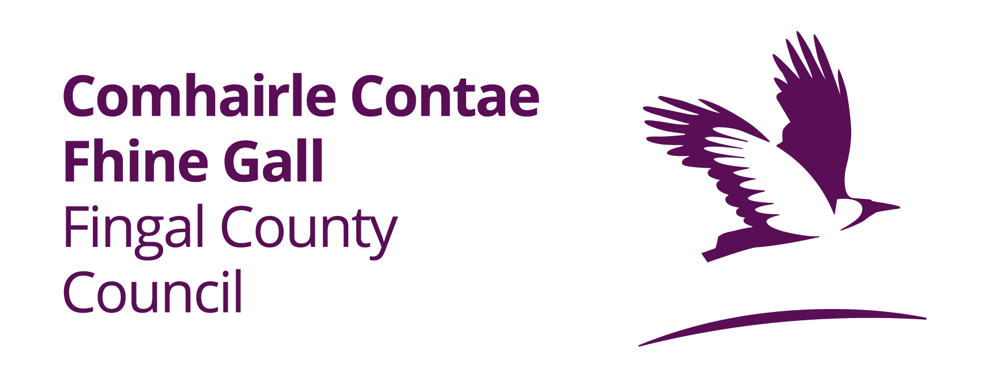

**ROADS ACT 1993 TO 2023– SECTION 75**

**PROPOSED TEMPORARY CLOSURE OF BHAILE AN RÓLAIGH ROAD, ROLESTOWN, CO. DUBLIN**

An application has been received from GMC Utilities Ltd on behalf of Uisce Eireann for permission to temporarily close Iostáin Bhaile an Rólaigh Road, Rolestown, Co. Dublin for the purpose of installing a drinking water connection. It is proposed that the road will be **closed on the 3rd July 2025 from 00.00am to 23.59pm.**

**Alternative routes available for vehicular traffic are as follows:**

1. Traffic travelling from Oakhill on Rolestown West, No right turn onto Ceide Bhaile an Rolaigh, follow diversion left, Follow road until right turn onto Barnanstown, follow road onto Lispopple . Westbound traffic travelling on Oakhill will be notified at Balcultry road junction/R125 & on the Rath Lane to prevent traffic encountering the road closure and follow diversion route provided
2. Traffic travelling north on Lispopple, No left turn onto Ceide Bhaile an Rolaigh, follow diversion signs on Lispopple, follow road onto Barnanstown, left turn onto Rolestown West . Follow road around to junction with Ceide Bhaile an Rolaigh.  Similar to above traffic will be notified of road closure at Balcultry road junction/R125 to prevent traffic encountering the road closure and follow diversion route provided

 Diversion route B

1. Traffic travelling south on Rolestown West, follow diversion right until left turn onto R125/Oakhill, Follow road until left turn onto Lispopple. Follow the road until junction with Ceide Bhaile an Rolaigh.
2. Traffic travelling south on Lispopple, No right turn onto Ceide Bhaile an Rolaigh, follow diversion straight until right turn onto R125/Oakhill, Follow road until right turn onto Rolestown West.

**Local access will be allowed from junction with Rolestown West. Emergency services access will also be made available in the event of an emergency.**

**Any person may lodge an objection online through the Consultation Portal, at https://consult.fingal.ie, or in writing to the Senior Executive Officer, Balbriggan, Rush-Lusk, Swords Operational Area, Fingal County Council, Grove Road, Blanchardstown, Dublin 15, to arrive no later than 12.00pm on the 17th June 2025.**

**Administrative Officer**

**Balbriggan/Rush-Lusk/ Swords Operational Area**

All comments, including the names of those making comments, which are submitted to the Council regarding this Temporary Road Closure will publicly be visible on the consultation website of Fingal County Council.