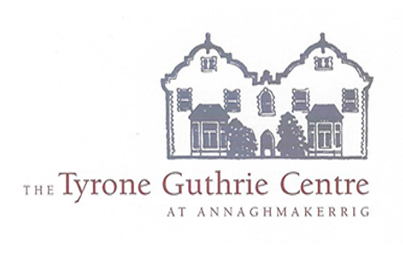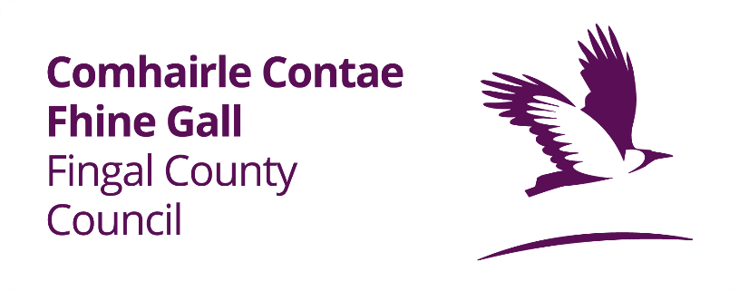

Fingal County Council, Age & Opportunity and Tyrone Guthrie Centre Residency Award 2025
Deadline 5pm, Monday 9th June 2025

Application Form

Please read the award guidelines before completing the online application form.
Deadline for submission: 5pm, 9th June 2025
First Name:
Last Name:
Address (including Eircode):
County:
Email Address:
Phone Number:
Artform
- visual art
- architecture
- music
- media
- performing art
- literature
- circus
- community art
- traditional art
- public art
- film
- other (please specify)

Have you ever availed of a residency in Tyrone Guthrie Centre before? If Yes, please provide some detail (100 words)
Please describe your artistic practice including your art form(s) (50 words)
How would this award contribute to your development as an artist? (100 words)
Please describe the project you would work on during the residency (max 300 words)
Please indicate your connection to Fingal as per eligibility (100 words).
Eligibility: To be eligible to apply the applicant must have been born, have studied, or currently reside in the Fingal administrative area. Applicants must be emerging or professional practicing artists and must meet the eligibility requirements.

Please see link to map of Fingal https://2ua.org/irl/l/fingal/map/

Born: Applicants must state in their application where they were born or grew up in Fingal and must include their address.

Studied: Applicants who attended primary level, secondary level schools in Fingal. All educational institutions must be located in Fingal. The applicant may have grown up outside Fingal but attended school in Fingal. Applicants must state the name and address of the school they attended in Fingal in the application form.

Please attach to your submission the following documents:
- CV
- Short Biography (300 words)
- Professional Reference 1
- Professional Reference 2
- Example of Work 1
- Example of Work 2
- Example of Work 3

Checklist for Application
- Completed application form
- I have read the application guidelines
- I am willing to complete a short report at the end of the residency.

These last few questions allow us to gather information on the diversity and inclusivity of our programmes and we appreciate you taking the time to answer them.

What is your age?
o50 – 60
o61 – 70
o71 – 85
o86 or older
oPrefer not to say

What is your gender?
oFemale
oMale
oNon-binary
oOther (specify if you wish)
oPrefer not to say

What is your ethnic or cultural background?
oAsian or Asian Irish: Chinese
oAsian or Asian Irish: Any other Asian background
oBlack or Black Irish: African
oBlack or Black Irish: Any other Black background
oWhite: Irish
oWhite: Irish Traveller
oWhite: Any other White background
oOther including mixed background (specify if you wish)

