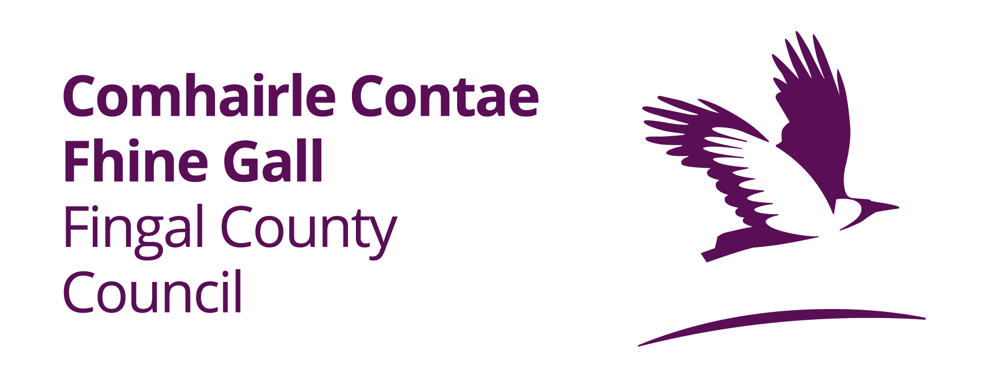

**ROADS ACT 1993 TO 2023– SECTION 75**

**PROPOSED TEMPORARY CLOSURE OF VARIOUS ROADS IN SKERRIES, CO. DUBLIN**

An application has been received from Fingal Triathlon Club for permission to temporarily close various roads in the Skerries area for the purpose of facilitating the bike course for the Skerries Triathlon. It is proposed that the roads will be **closed from 08.00am to 12.00pm on Sunday 22nd June 2025.**

**The roads in question are:**

• Red Island to Harbour Road

• Harbour Road to Quay Street

• Quay Street to Hoar Rock

• Hoar Rock to White Cottages

• Portion of Balbriggan Street

• Portion of Thomas Hand Street

• Portion of Strand Street

**Alternative routes available for vehicular traffic are as follows:**

**Access from Skerries to Balbriggan**

Take R128 direction Rush to Loughshinny. At crossroads turn right onto L1285. L1285 via Baldungan turn left at T junction onto main Skerries Lusk Road (R127). R127 direction Lusk. Take 1st exit at roundabout via Lusk Bypass Ring Road. Take 2nd exit at roundabout continue R127. Take 2nd exit at roundabout junction with Rush Road R127. Take 1st exit at roundabout R127 to Blakes Cross. Turn right onto R132. Continue R132 to roundabout at M1 Business Park. Take 3rd exit on roundabout R132. Continue R132 via Balrothery to Balbriggan

**Access from Balbriggan to Skerries**

R132 via Balrothery to M1 Business Park roundabout. Take 1st exit onto R132 to Blakes Cross. Turn left onto R127 to Lusk. At roundabout take 2nd exit onto Lusk Bypass Ring Road R127. At Rush Road roundabout take 2nd exit continue R127. At roundabout take 2nd exit continue R127. At Skerries Road roundabout take 2nd exit on R127 towards Skerries. At T junction turn right onto L1285 direction Loughshinny. L1285 via Baldongan to crossroads Loughshinny. Turn left at crossroads onto R128 direction Skerries

**Local access will be maintained at all times. Emergency Services access will also be made available in the event of an emergency.**

**Any person may lodge an objection online through the Consultation Portal, at https://consult.fingal.ie, or in writing to the Senior Executive Officer, Balbriggan, Rush-Lusk, Swords Operational Area, Fingal County Council, Grove Road, Blanchardstown, Dublin 15, to arrive no later than 12.00pm on Tuesday 27th of May 2025.**

**Administrative Officer**

**Balbriggan/Rush-Lusk/ Swords Operational Area**

|  |
| --- |
| All comments, including the names of those making comments, which are submitted to the Council regarding this Temporary Road Closure will form part of the statutory report to be presented to the monthly meeting of Fingal County Council. |