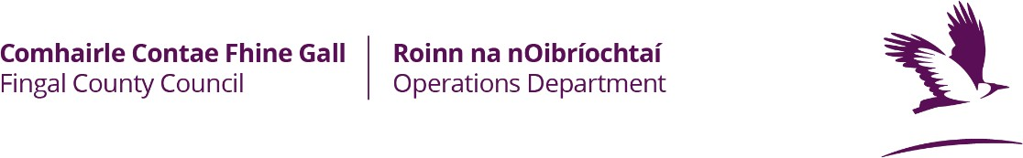

School Application for Playing Pitch
For Official Use Only | Total No | Amount Due
Teams
Admin Fee
Total

Season 2023-2024

Form to be filled in Block Capitals
Name of School

Please complete this section in full
Mobile Home/Work
Contact Email Address:

Does your School have a Current Public Liability Insurance policy Yes/No
Is Fingal County Council specifically indemnified on your policy Yes/No

Insurers | Policy Start Date | Expiry Date | Policy No

 | No. of Teams | Code  *see below | League | Playing Day | Playing Times am/pm | Season From Month | Season to Month
u/8
u/9
u/10
u/11
u/12
u/13

u/14
u/15
u/16
u/17
u/18
Total Teams

Codes
Soccer | Gaelic Football | Hurling | Camogie | Rugby | Cricket | Other
S | GF | H | CAM | R | CK | O

For Midweek Fixtures see General Conditions of Letting
Pitch Accommodation last Season (state location) | - Fingal County Council

CLUB COLOURS: HOME: AWAY:

I hereby certify that I have read and accept the Conditions of Pitch Allocation and certify that the information contained within this application is true and I agree that any inaccuracies regarding the information or breach of the conditions may result in your school having its allocation for all its teams withdrawn for a period of up to one calendar year.

Signature of School Official making application: (please note, all correspondence will be directed to this person)

Signature: ______________ Position Held:

Block Capitals

Check List : 1. Completed Application Form Y/N
- Letting Fee (To follow in August when school office reopens) Y/N
- Insurance (with indemnity to Fingal County Council) Y/N
Tick as appropriate

Tá leagan Gaeilge den fhoirm seo ar fail

