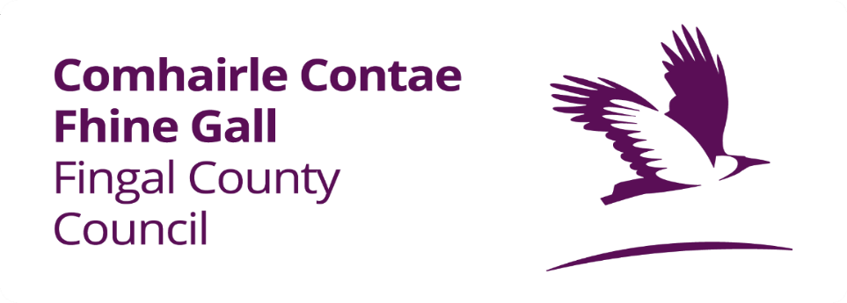
APPLICATION FOR CONNECTION/DIVERSION TO THE STORMWATER

Please return the completed Application Form to:
Fingal County Council,
Water Services,
Blanchardstown,
Dublin 15, D15 W638

Tick The Appropriate Box

Connection. Diversion.

Applicant Details:

Name
Address
Eircode
Telephone
Email

Contractor/ Site Agent Contact Details:

Name
Address
Eircode
Telephone
Email

Planning Details:

Planning Application No.
Date Granted.

Surface Water Connection Details:

Connection Address
Eircode

You must provide an Ordnance Survey of Ireland National Grid Reference for the proposed connection point to a public surface water sewer. If the connection point is not known, a reference point for the main entrance of the property from the public road must be provided.

OSI National Grid Reference:
Easting (X) Northing (Y)

Number of Connections:

Connection Size (mm) | Pipe Material of new connection | Length (m) | Depth of Sewer (m) | Location of Sewer

Applicant Undertaking:

I/We confirm that to the best of my knowledge the information provided in this application to be correct, and I/We hereby undertake that all work to be carried out in accordance with Fingal County Council’s rules and regulations.

Signed_____________________________________ Dated_______________________________

Road Opening Licence:

If any public area is being opened (i.e. road, footpath or grass margin) a Road Opening Licence must be obtained from the Council’s Operations Department, Grove Road, Blanchardstown, Dublin 15, Tel: 01-8704599. Please include your Approval Number as issued by Water Services, on your application for a Road Opening Licence.

Important Notes:

Surface Water and Foul Sewer systems must be kept separate; under no circumstances can surface water be discharged to the foul sewer system.

All Connections to public sewer must be made under the supervision of the Council’s Drainage Inspector to whom due notice must be given.

All connections made without Council supervision will be deemed as an Unauthorised Connection and will carry a penalty fee payable to Fingal County Council, upon penalty fee not being paid within two weeks of notice; the connection will be disconnected by Fingal County Council at the expense of the Applicant on reconnection.

Illegally connecting to the wastewater network is in breach of the Water Services Act 2013 and is a criminal offence.

Check List:

Completed & Signed Form
Submission of Site Location Map
Submission of Design Schematic Layout
Submission of As Constructed Drawings
Application will not be processed unless the above documentation is attached.

Tá leagan Gaeilge den fhoirm seo ar fáil.

