Balbriggan Shopfront Painting, Signage and Improvement Contribution Scheme 2023

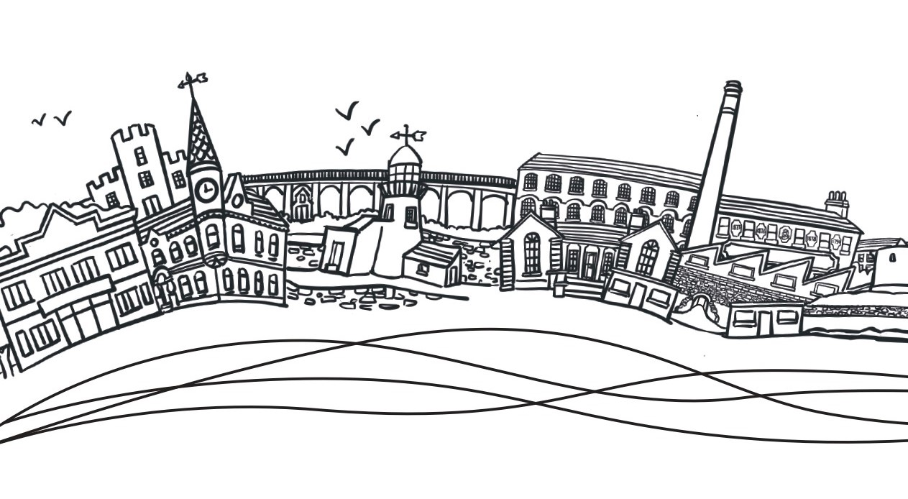

Application Form

Applications must be received by the Our Balbriggan Office on or before 12:00 noon Friday 24th May 2023. Completed application forms and supporting documents can be emailed to Ourbalbriggan@fingal.ie or hand delivered to the Our Balbriggan Office, Georges Square , Main street Balbriggan, Co. Dublin. Eligible Streets under the scheme will include Dublin Street, Bridge Street, Drogheda Street, Railway Street and Quay Street. All works must be completed by June 30th to avail of funding.

Please complete all sections below:

Applicant’s name:

Contact email address:

Contact telephone phone no:

Full address of property:

Property owner or tenant:

If tenant, please specify length of lease remaining

Amount of Contribution funding requested:

Please sign to confirm you agree to the accompanying terms and conditions of the Scheme:

Project Proposal - Please outline works proposed in detail (see more details on possible works at the end of this form)

Details of Works: Complete as appropriate. Maximum €1,500 per building.

Details of Works | VAT Excluded | VAT Included
Shopfront Repair/Signage Replacement

External Painting/ Decluttering

Green Enhancement of Building

Maximum funding available for one
building €1,500
Total Project Cost

- Please provide your VAT number.

- Detailed Description of Works. (Please attach additional details to the application form if required)

3. If you are a tenant, has the property owner provided written consent for these
works to take place

SUPPORTING DOCUMENTATION REQUIRED WITH THIS APPLICATION:
  - One Quote for each proposed project works
  - Photograph of building prior to proposed works
  - Letter of consent from property owner if not the property owner
  - Businesses/Organizations will be asked for the company/group VAT number
  - Tax Clearance certificate prior to grant payment.

Balbriggan Shopfront Improvement Contribution Scheme 2023 Terms & Conditions.

Outline of Measure

Fingal County Council Regeneration Office together with the Our Balbriggan Office are launching a shopfront painting, decluttering, signage and improvement scheme for Balbriggan. Contributions to a maximum amount of €1,500.00 can be applied for – eligible streets to include Dublin Street, Bridge Street, Drogheda Street, Mill Street, Quay Street and Railway Street. All shopfront improvement projects to be completed by 30th June 2023.

Eligible Premises

Commercial and Shopfront improvements - Dublin Street, Bridge Street, Drogheda Street, Mill Street, Quay Street and Railway Street, Balbriggan.

Eligible Works

- Works to individual commercial properties.
- Eligible works include painting, shopfront improvement, decluttering signage and planting.

Improvement Contribution Scheme
Funding can be provided up to a maximum of €1,500.00. Retrospective payments will be made once all works are completed and satisfactory evidence of completion of payments are provided as detailed in the payment/award section below.

Quotations

As per National Procurement Guidelines one quotation must be provided for each project element

Closing date

Application forms must be received by Our Balbriggan Office on or before 12:00 noon on Wednesday May 24th 2023. Email the application form and supporting documents to ourbalbriggan@fingal.ie or hand-deliver your application form along with all supporting documentation Our Balbriggan Hub, George’s square, Main Street Balbriggan, Co. Dublin.

Completion of works
All approved works must be completed by 30th June 2023.

Successful applications will require

- Completed Application Form.
- Accompanying Quotation documents for each project element
- Letter of Consent from property owner if applicant does not own the property.

Payment of contribution/funding will require

  - Photograph of works area prior to commencement of project.
  - Photograph of completed project.
  - Evidence of payment – i.e., bank statement extract showing payments, receipts & Invoices.
  - Evidence of registration for VAT where applicable
  - Tax clearance certificate for businesses/organizations.

Funding Conditions

Non-Compliance with the conditions as outlined or non-compliance with any other scheme conditions may result in the requirement to refund part or all of the grant aid awarded.

Application Form
Please ensure that you complete the 2023 application form in full and that any supporting documentation is submitted with your application.
Only projects that meet the criteria will be considered eligible.
PLEASE NOTE THAT INCOMPLETE APPLICATIONS OR LATE APPLICATIONS WILL NOT BE CONSIDERED.
Submission of false or misleading information at any stage is treated very seriously. Any applicant who does not comply with the terms and conditions of the Programme may, subject to inspection, have their grant withdrawn, be required to repay all or part of a grant and/or be barred from making applications for a period of time.

Letter of Offer – Eligible Dates for Purchases/Works

Only purchases or work carried out after successful applicants receive a Letter of Offer are eligible i.e., only receipts dated after the Letter of Offer date will be accepted as eligible.

Statutory Consents
Applicants must ensure that all necessary statutory permissions or consents have been obtained before any works commence. This includes but is not confined to planning permission.

Insurance

Written evidence of a valid insurance policy may be requested, where relevant, during the applications review process.

GDPR

To process your application, it may be necessary for Fingal County Council to collect personal data from you. Such information will be processed in line with the Local Authority’s privacy statement which is available to view on the Fingal County Council website.

When you give us personal information, you have rights regarding how this information is used. Fingal County Council has a duty to keep your details private and safe. The EU General Data Protection Regulation (EU) 2016/679 and Data Protection Act 2018 mean that Fingal County Council must be fair in how it handles and stores any personal information we collect. The Acts protect personal privacy and rights of individuals by restricting how the Council uses and shares your personal information.

All information provided in respect of the application for a grant will be held electronically. The Department reserves the right to publish a list of all grants awarded on its website.

Payment of Funding
Once you have received your letter of offer, you will be issued with a Fingal County Council supplier ID form. On this form you will be required to fill in your bank account details such as your BIC & IBAN from your nominated bank account. These details will be added to Fingal County Council’s payment system to enable transfer of approved funding to your bank account once all works are completed.

Freedom of Information Act 2014
Fingal County Council is bound by the Freedom of Information Act 2014.

Site Visits
The Department of Rural & Community Development or Fingal County Council may carry out unannounced site visits to verify compliance with Program terms and conditions.

Further information may be requested
Fingal County Council reserves the right to request further information from you to assess your application if so required.

Queries on this Scheme

For any queries on this scheme please contact the Our Balbriggan Team at ourbalbriggan@fingal.ie or call 01 8905000.
Appendix 1

ELIGIBLE WORKS AND MAXIMUM FUNDING FOR EACH PROPERTY
Green enhancement of entrances/ terraces with planting
Painting of building/shop front in carefully selected colours which will complement the host building and streetscape
Maximum grant per building | €1,500.00

