SCHOOL APPLICATION FORM
For Bicycle and Scooter Racks
Please send your completed form to Active.Travel@fingal.ie
CONTACT DETAILS

Name of School
Address
School Principal
School’s Green Officer
Email
Phone no.
ABOUT YOUR SCHOOL

How many children are enrolled in the school?
How many staff are employed by the school?
Are you participating in An Taisce’s Green Schools programme? |  | Yes / No
Does your school have a school travel plan? |  | Yes / No
How many children cycle to your school? (Estimate)
How many children scoot to your school? (Estimate)
How many bicycle parking spaces do you currently have?
Do you have scooter parking racks? |  | Yes / No
Have you previously received bicycle or scooter racks from the National Transport Authority or Fingal County Council? |  | Yes / No
Requested Bicycle and Scooter Racks
Number of bicycle and Scooter Racks requested. (max 5 No. of each) |  | Number of racks
Toast Racks (5 Hoop) – Parks 10 bicycles
Approximate Dimensions: 3.2 meters (length) x 0.75 meter (Height) x 0.750mm (Width) – Most Suitable for Senior or Secondary Schools

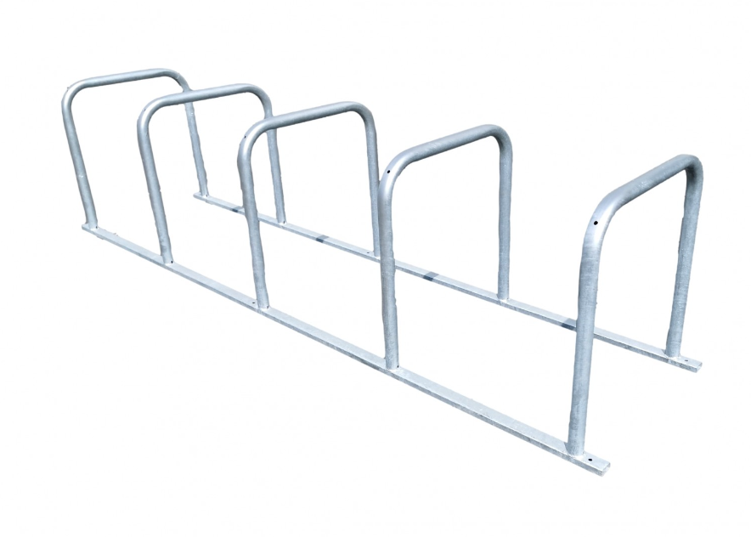

Scooter Racks – Parks 10 scooters
Approximate Dimensions: 1.050 meters (Length) 1.2 meters (Height) x x 0.42 meters (Width)

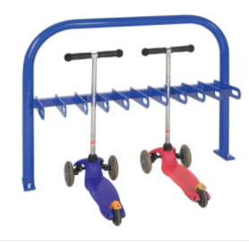
Low Profile Racks (Suitable for smaller bikes or Junior Primary Schools)
Approximate Dimensions: 1.32 meter (length) x 0.27 meters (Height) x 0.35 meters (Width) – Capacity 5 Bikes

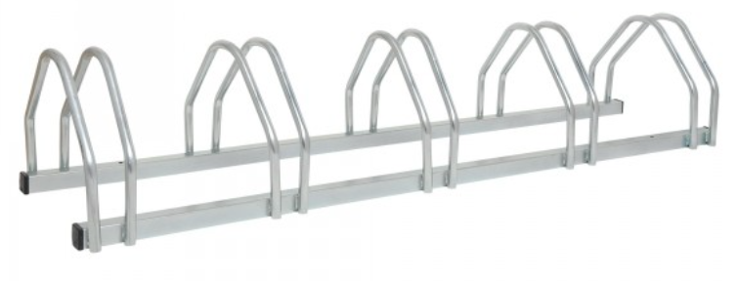

* Please check dimensions of racks before applying to ensure that the sizing is suitable for your school.

SIGNED: DATE:
___________________ ________________

