CLUB APPLICATION FORM
For Bicycle and Scooter Racks
Please send your completed form to Active.Travel@fingal.ie
CONTACT DETAILS

Name of Club
Address
Club Chairperson
Child Welfare Officer
Email
Phone no.
ABOUT YOUR CLUB

How many children/adults cycle to your club? (Estimate)
How many staff are employed by the club?
How many children/adults scoot to your club? (Estimate)
How many bicycle parking spaces do you currently have?
Do you have scooter parking racks? |  | Yes / No
Have you previously received bicycle or scooter racks from the National Transport Authority or Fingal County Council? |  | Yes / No
Requested Bicycle and Scooter Racks
Number of bicycle and Scooter Racks requested. (max 5 No. of each) |  | Number of racks
Toast Racks (5 Hoop) – Parks 10 bicycles
Approximate Dimensions: 3.2 meters (length) x 0.75 meter (Height) x 0.750mm (Width) – Most Suitable for Senior or Secondary Schools

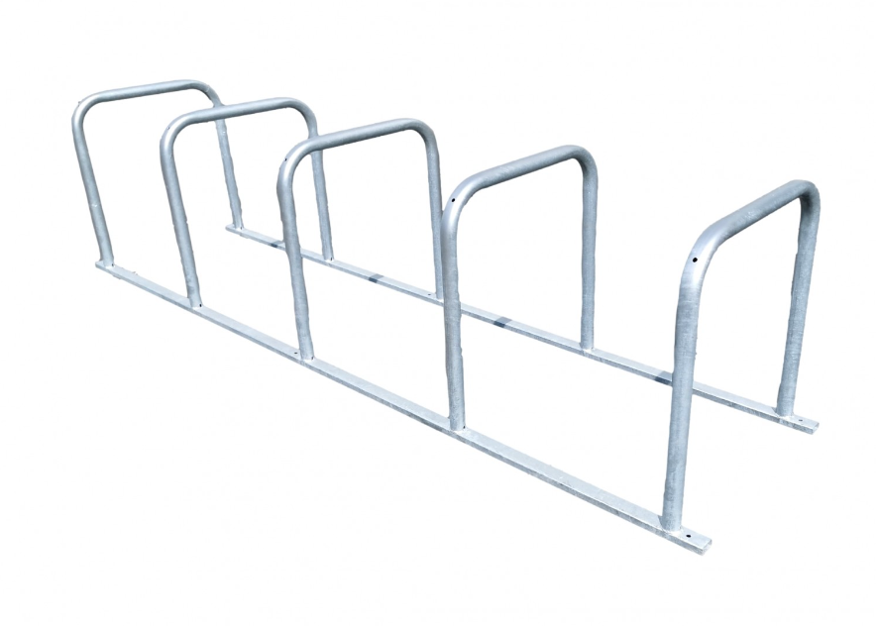

Scooter Racks – Parks 10 scooters
Approximate Dimensions: 1.050 meters (Length) 1.2 meters (Height) x x 0.42 meters (Width)

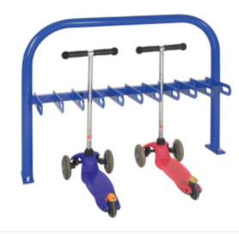
Low Profile Racks (Suitable for smaller bikes or Junior Primary Schools)
Approximate Dimensions: 1.32 meter (length) x 0.27 meters (Height) x 0.35 meters (Width) – Capacity 5 Bikes

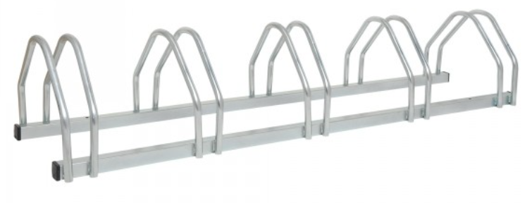

* Please check dimensions of racks before applying to ensure that the sizing is suitable for your club.

SIGNED: DATE:
___________________ ________________

