COMMUNITY CENTRE APPLICATION FORM
For Bicycle and Scooter Racks
Please send your completed form to Active.Travel@fingal.ie
CONTACT DETAILS

Name of Community Centre
Address
Centre Manager
Email
Phone no.
ABOUT YOUR CENTRE

How many children/adults cycle to your centre? (Estimate)
How many staff are employed by the centre?
How many children/adults scoot to your centre? (Estimate)
How many cycle stands do you currently have?
Do you have scooter parking?
Have you previously received bicycle or scooter racks from the National Transport Authority or Fingal County Council? |  | Yes / No
Requested Bicycle and Scooter Racks
Number of bicycle and Scooter Racks requested. (max 5 No. of each) |  | Number of racks
Toast Racks (5 Hoop) – Parks 10 bicycles
Approximate Dimensions: 3.2 meters (length) x 0.75 meter (Height) x 0.750mm (Width) – Most Suitable for Senior or Secondary Schools

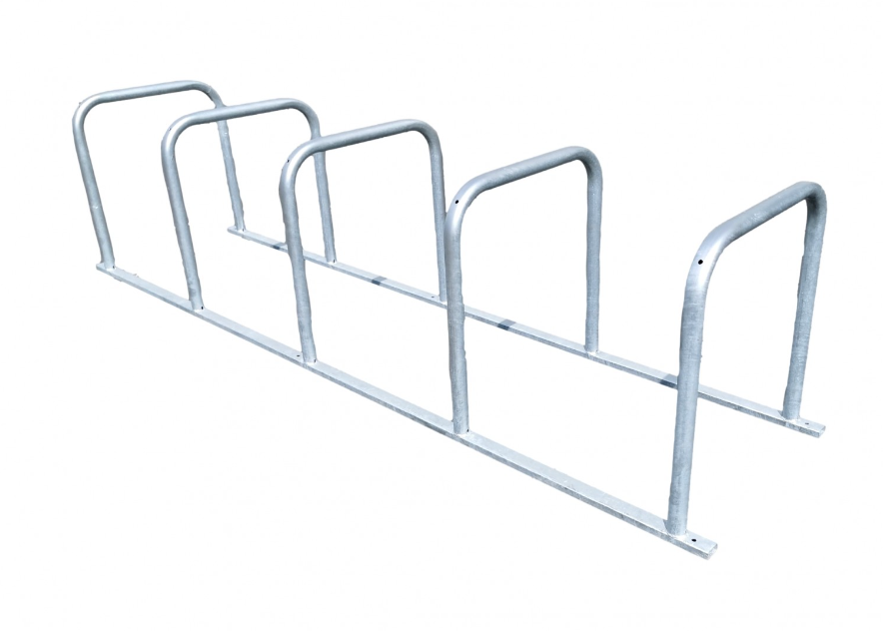

Scooter Racks – Parks 10 scooters
Approximate Dimensions: 1.050 meters (Length) 1.2 meters (Height) x x 0.42 meters (Width)

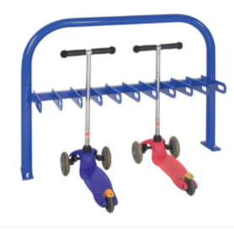
Low Profile Racks (Suitable for smaller bikes or Junior Primary Schools)
Approximate Dimensions: 1.32 meter (length) x 0.27 meters (Height) x 0.35 meters (Width) – Capacity 5 Bikes

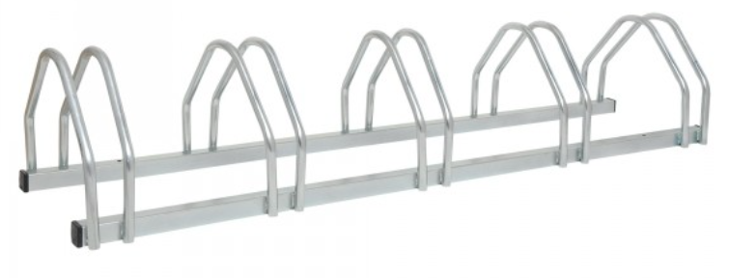

* Please check dimensions of racks before applying to ensure that the sizing is suitable for your centre.

SIGNED: DATE:
___________________ ________________

