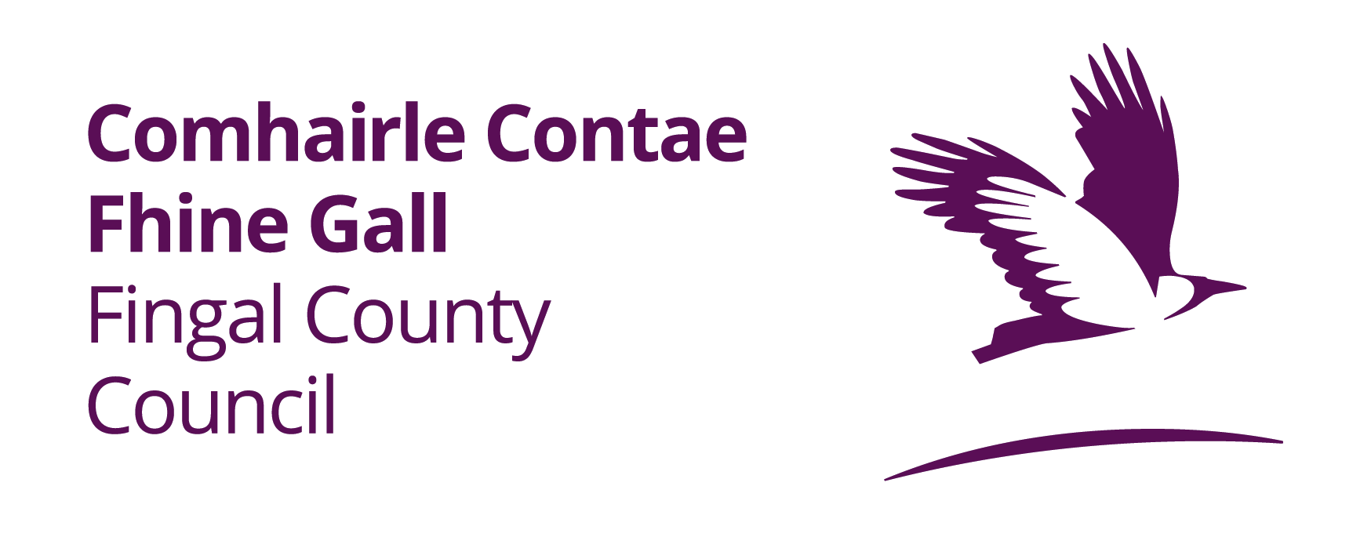

Fingal County Council Beach Lifeguard Application 2023
The latest date for accepting completed applications is 5.00pm on Friday 24th February, 2023

Where copies of certificates etc are required please do not send original documents.

Misleading statements will render an applicant liable to disqualification.

- PERSONAL DETAILS
a. Name in full (Block Letters): __________________________________________

b. Address (Block Letters): ____________________________________________

____________________________________________

c. Contact Number: ____________________________________________

d. Please confirm if you are 18 years or over? Yes No

e. Email Address: _____________________________________________________

- AVAILABILITY

a. What is your current occupation: __________________________________________

b. If offered employment what date would you be available to take up duty:
____________________________ (Bathing Season commences Saturday 3rd June, 2023)

c. Outline your availability for each month

June (weekend work only) _________________________________________________

July ____________________________________________________________________

August __________________________________________________________________

September (weekend work only) ____________________________________________

I declare all of the above to be true Yes No

NOTE: Periods of leave in excess of 2 consecutive days will not be authorised

- EDUCATION
 | Dates  From To | Name of School /  University | Examination
2nd LEVEL

3rd LEVEL

OTHER

- WATER SAFETY/LIFE-SAVING QUALIFICATIONS

No candidate will be offered a Beach Lifeguard post until a current Beach Lifeguard Certificate has been received by the Council (Irish Water Safety / Royal Life Saving Society or equivalent accepted).

a. BEACH LIFEGUARD CERTIFICATE
Issued By: _________________________ Date of Issue: ____________________________

If your qualification is due to be renewed state Renewal Date: _______________________
b. RESCUE CERTIFICATES

______________________________________________________________________________

______________________________________________________________________________

______________________________________________________________________________

c. BASIC LIFE SUPPORT / FIRST AID (including AED Training)

______________________________________________________________________________

______________________________________________________________________________

______________________________________________________________________________

d. DETAILS OF OTHER RELEVANT QUALIFICATIONS (including Boat Competency, VHF Radio etc.)

______________________________________________________________________________

______________________________________________________________________________

______________________________________________________________________________

DETAILS OF ANY OTHER RELEVANT QUALIFICATIONS SHOULD BE LISTED ON ONE ADDITIONAL PAGE AND SUBMITTED WITH THIS FORM

- DETAILS OF PREVIOUS BEACH LIFEGUARD EXPERIENCE / POOL LIFEGUARD EXPERIENCE OR OTHER RELEVANT EXPERIENCE

From To | Name and Address of Employer | Details of Employment

- AUTHORISATION
Garda Vetting - Signed Declaration: (Successful Applicants will be required to complete a Garda Vetting Form)

I hereby authorise An Garda Síochána to furnish Fingal County Council with a statement that there are no convictions recorded against me, or a statement of any convictions against me, as the case may be.

Applicant’s Signature: ____________________________________

- REFERENCES
Give the names of two responsible people to whom you are well known, but not related, who may be contacted by Fingal County Council

Name: ______________________________ Name: ______________________________

Occupation: ________________________ Occupation: _________________________

Address: _____________________________ Address: ______________________________

_____________________________ ______________________________
Tel No: _____________________________ Tel No: ______________________________

Email: _____________________________ Email: _____________________________

I, the undersigned, hereby declare all the foregoing particulars to be true.

Signature of Applicant _______________________________ Date ________________

NOTES

- Application Forms will be received only via email to careers@fingal.ie The Latest date for receipt of completed application forms is Friday 24th February 2023 at 5.00pm

- Applications must be submitted as Microsoft word or PDF document format only.

- Candidates may be short-listed on the basis of the information supplied on their application form.

- Applicants are requested NOT to submit original or copied documentation e.g. Birth Certificate, Educational Certificates and references with this application form.

- Applicants must NOT submit Curriculum Vitae with this application form.

- All records relating to the interview will be held on file for one year, after that time they will be securely disposed of by Fingal County Council.

