Photo Explainer on how to use the Communication Board
 | 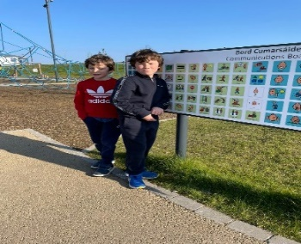 | Image description  Two children standing at a Communications Board.
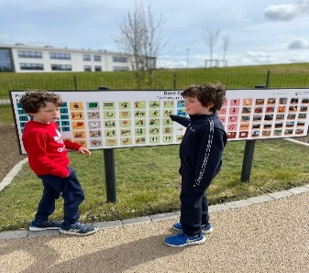  Step 1 Two children using a Communication Board. First child points to a symbol on the board to show the second child. | 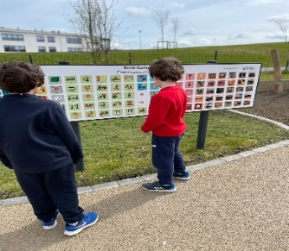  Step 2 Two children using a Communication Board. The second child points to a symbol on the board to respond to the first child.
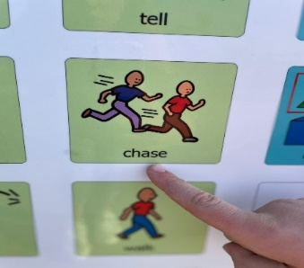  Step 1 A close up of first child’s finger pointing to the symbol on the board for ‘chase’ to show the second child. | 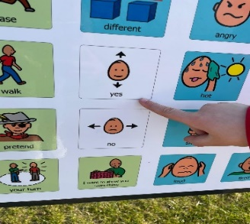  Step 2 A close up of second child’s finger pointing to the symbol on the board for ‘yes’ to respond to the first child. | 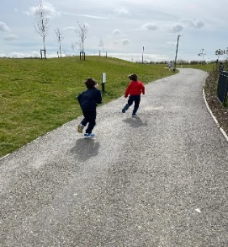  Step 3 Two children playing ‘chase’.
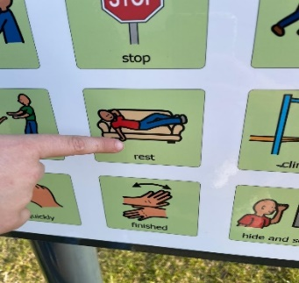  Step 1  A close up of first child’s finger pointing to the symbol on the board for ‘rest’ to show the second child. | 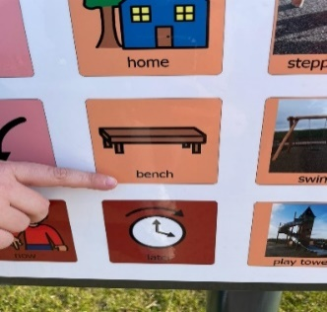  Step 2  A close up of second child’s finger pointing to the symbol on the board for ‘bench’ to show the first child. | 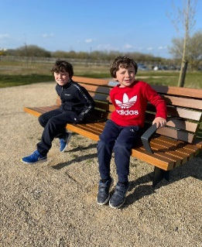  Step 3  Two children resting on a bench.

