Seeking team to lead new community singing group in Swords

* Fingal County Council to support new multicultural community singing group in Swords, as part of the One Town One Voice initiative
* Singing group to reflect cultural diversity in Swords today
*Calling for community members to lead the group, both musically and organisationally

Fingal County Council is pleased to partner with the One Town One Voice initiative in establishing a multicultural singinging group for the community of Swords.
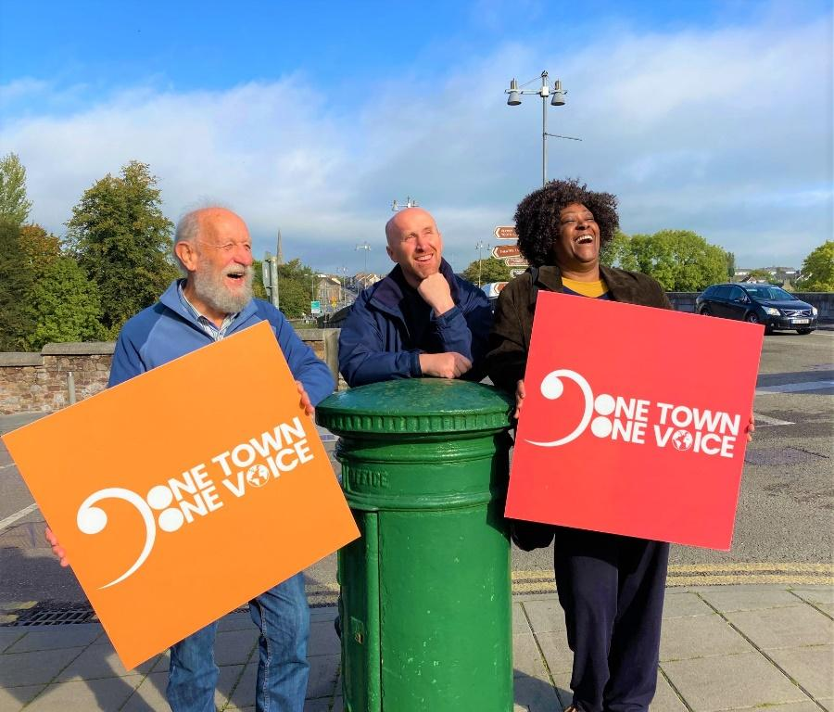
The One Town One Voice initiative aims to establish secular community singing groups made up of Irish people and those who have moved to towns from other countries in recent years. The aim is to use communal singing to bring people together regardless of nationality, enable and enhance greater community integration and build closer communities.
Towns can take part in the initiative by establishing adult singing groups that are open to all (no audition required!), and seeking a diverse membership that reflects the beautiful cultural diversity of your town.

Fingal County Council are happy to support a new ‘One Voice Singers’ group in Swords, which is the fastest growing town in Europe and home to people of many cultures and backgrounds.

Our vision is that ‘The One Voice Singers - Swords’ will be a true community group, lead by members of the community, in partnership with the community. Our goal is to enable and encourage connections between people who might otherwise not meet or would not feel part of the same community, and then to help those connections flourish...all the while having great musical fun!

We are now seeking community members who are interested in leading the group to contact us at Community@fingal.ie with an expression of interest. Let us know what draws you to this initiative, and in what way you would like to help the running of the group.

In particular we seek individuals interested in joining our core team as:

- Musical Lead - to lead and conduct the singing group, in weekly rehearsals and occasional performances. Previous experience leading choirs or singing groups is desirable, but not essential. One Town One Voice can provide musical advice for working with multicultural groups, and will liaise with the musical lead to build a network of similar singing groups around Ireland, and plan events and occasional media coverage.

- Group Motivator - Someone who works alongside the musical lead in ensuring each rehearsal, performance and event is welcoming and light-hearted, with the theme of inclusion always present. The Group Motivator will also be a point of contact for the One Town One Voice team, helping us to connect our singing groups across Ireland, and coordinate events and occasional media coverage. A volunteer position.

- Helpers - Additional people to support group operations, such as organising a rota for after-rehearsal treats, coordinating social nights, event planning, etc. Volunteer positions.

We look forward to hearing from you! For more information on the One Town One Voice initiative please visit our website at www.onetownonevoice.ie , or feel free to contact us at info@onetownonevoice.ie .

To express your interest in joining our singing group as a community lead please email community@fingal.ie

Recent media coverage: https://www.independent.ie/regionals/dublin/fingal/fingal-choirs-invited-to-join-solidarity-through-song-initiative-42078542.html

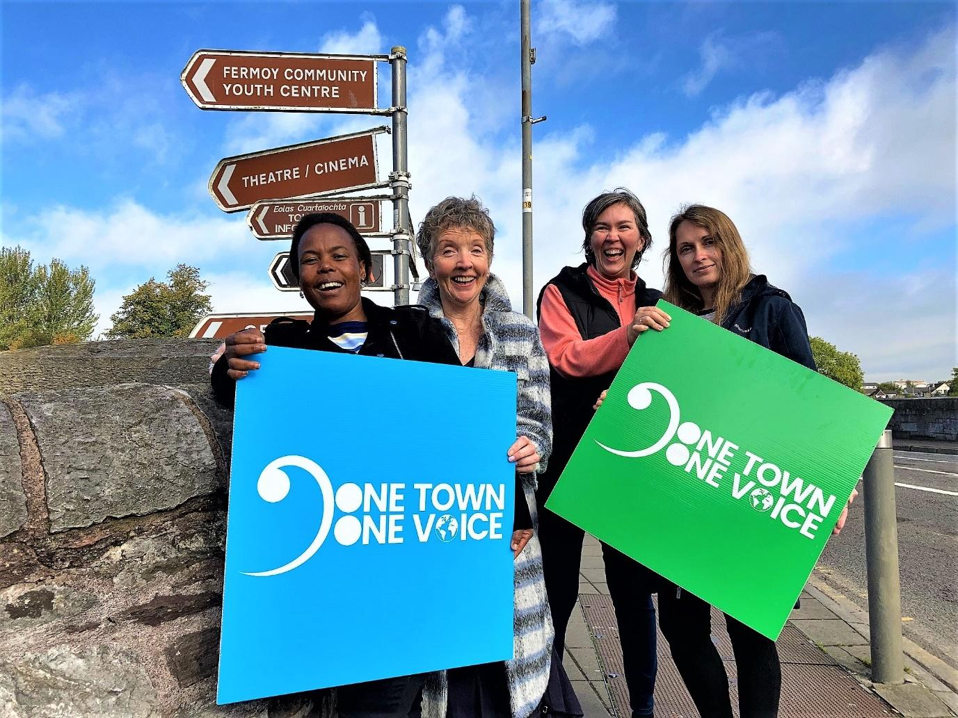

Captions: Photo 1: Members of the Fermoy International Choir (the pilot group for One Town One Voice): (L-R) Ted O’Leary, Roman Biletskyy (Ukraine) and Jelvon Doran (UK/Antigua)
Photo 2: Members of the Fermoy International Choir (L-R) Jackie Mocheko (South Africa), Eileen Barry, Dalia Biletskyy and Elena Bilozor (both Ukraine).

