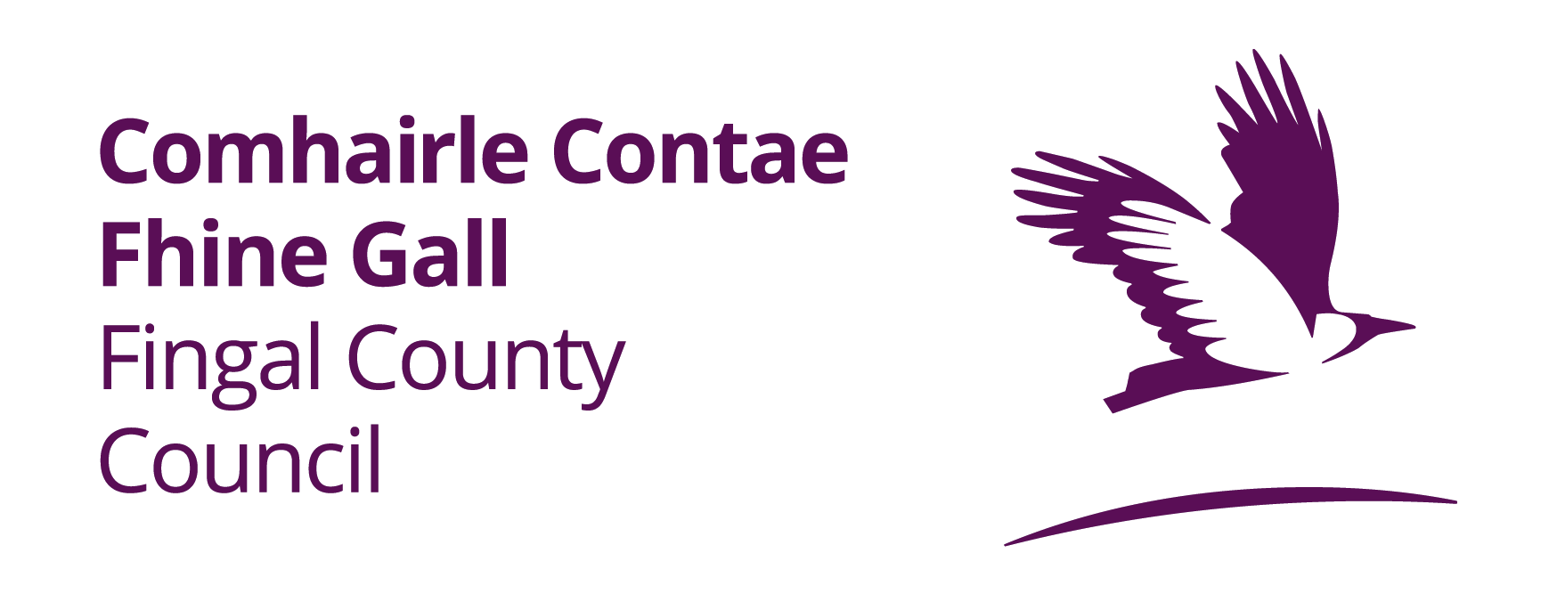
Applications are invited for the following position

Shift Plant Operator – LEIXLIP WATER TREATMENT PLANT

WAGES: €771.97 - € 822.59 per week

Persons who are not serving local authority employees will be based on the minimum of the scale.

Application forms and particulars are available from
Fingal County Council, The Human Resources Department, 4th Floor, County Hall, Swords, Fingal, Co Dublin, Tel (01) 8905650, and at www.fingal.ie

Candidates may be shortlisted for the interview on the basis of information
supplied on their application forms.

The latest date for receipt of applications is Friday 6th May 2022 at 5.00pm

CANVASSING WILL AUTOMATICALLY DISQUALIFY

Fingal County Council is an equal opportunities employer

