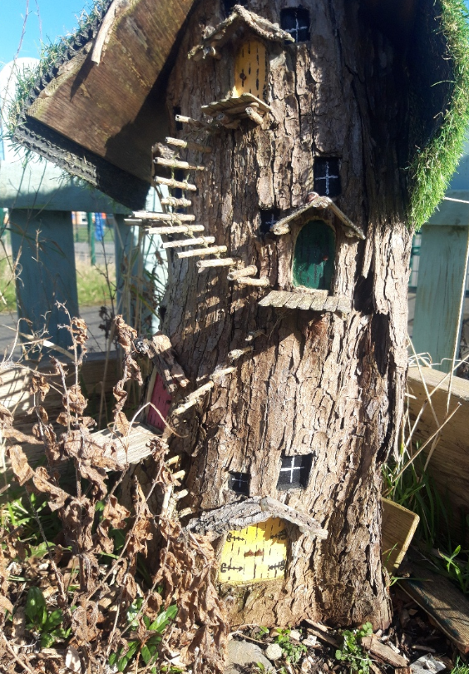
Activities in Nature Competition
CLOSING DATE is 4.30pm Friday 15th May 2020

Activities in Nature
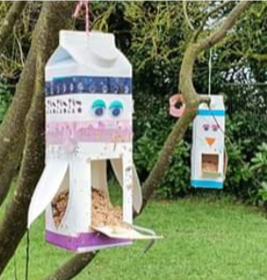
Try some of these fun nature activities and enter the competition!!
- Create a bird feeder from things at home.
- Make a bird Treat! Bird Feed – Pine cones or stones covered in Peanut butter and rolled in seeds.
- Paint stones, paint characters or your favourite designs.
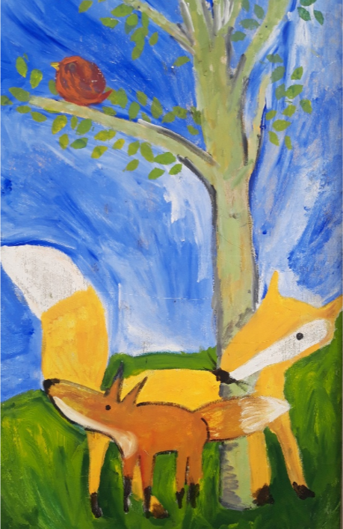
- Spot/ identify 3 different cloud types, write them down, draw the cloud shapes.
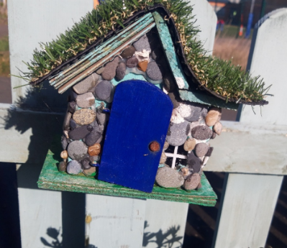
- Make some pressed flower or feather bookmarks.
- Identify 3 types of trees near your home (using leaf undergrowth and bark colour, buds, leaves), list what you find.
- Identify and record 3 native wild flowers around your home eg. daisy, dandelions, buttercup, birds-foot trefoil, sorrel, primrose.
- Build a ladybird home/ bug hotel.
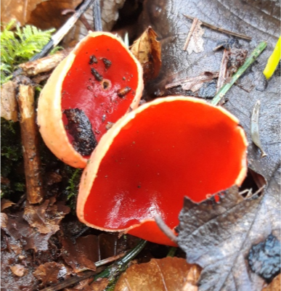
- Do a bug hunt- see what you can find- ladybirds, caterpillars, bees, snails, beetles, spiders, ear-wigs, flies or any other insects.
- Draw and colour a picture of your favourite Irish wild animal.
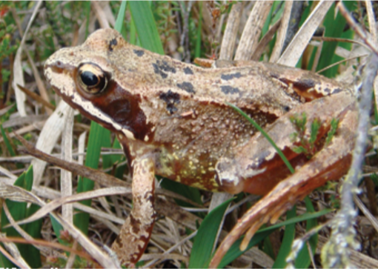
- Find 6 different types of insects or birds, write them down.
- Create a shallow mini-pond in a bucket.
- Find some fungus growth on trees/ wood/ walls.
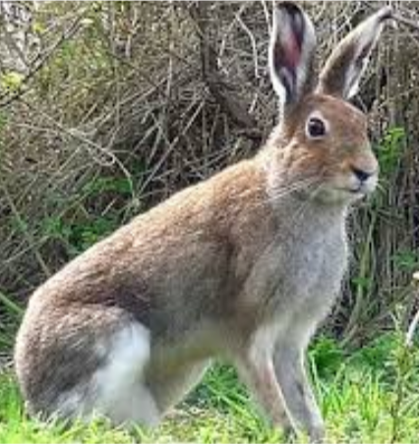
- Find some frog spawn in a slow-moving freshwater stream, visit it regularly and see the baby frogs in April…
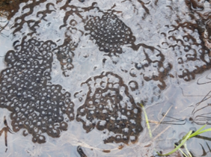
- Find a wild/ native ivy habitat and list five insects/ animals or birds that might live in it.
- Draw and colour 4 native woodland leaves, different shapes, e.g. Ash, Oak, Birch, Hazel.
- Draw and colour our native Irish frog!
- Draw and colour your favourite garden bird or sea bird.
- Draw and colour your favourite Irish sea creature.
- Draw and colour your favourite native Irish insect.
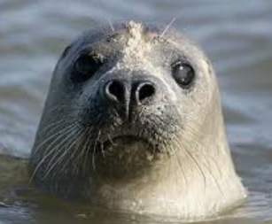
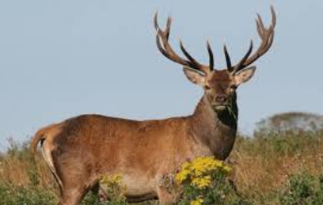
- Draw and colour an ancient Irish animal, e.g. great deer elk, woolly mammoth, bear.
- Choose your favourite Irish mammal, write down 5 facts about that mammal.
- Draw and colour your favourite native Irish bird.
- Draw and colour your favourite Irish wild mammal.

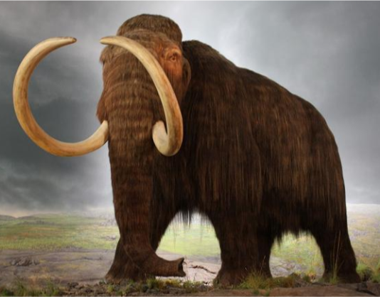
Competition Details
We have put together some great activities and we hope that you enjoy them!!
If you get 6 of the nature activities completed, you can enter into a competition to win a prize!!
We need these details to enter you into the competition:
- Name of entrant:
- Name of Parent giving consent to the child (U16) to enter this competition if applicable:
- Town/ Area/ Estate name:
- Email address:
- Age of child:
- Which age category are you?
- Age 4-6 age 7-9 age 10-12 age 13-15 Adult (16+)
- Which activities did you complete? (Mark your chosen 6 categories with an X)
- 1, 2, 3, 4, 5, 6, 7, 8, 9, 10, 11, 12, 13, 14, 15, 16, 17, 18, 19, 20, 21, 22, 23, 24

- (Optional feedback section) In your own words which aspect of the competition did you enjoy most? (up to 80 words max.).

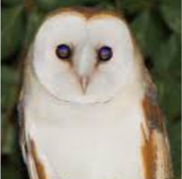
- Declaration of Consent: I parent/ guardian give consent to the above named child (U-16) to enter this competition: Name Yes/ No
- If pictures are submitted, do you parent/ adult give consent to Fingal County Council to use the submitted picture for social media purposes? (this is optional and does not affect your entry). Declaration: I give consent to Fingal County Council to use the submitted pictures for the purposes of social media Yes/ No
Print name of parent giving the aforementioned consent :

Competition conditions:
This competition is open to all, However only residents of Fingal and Fingal staff and their families will be eligible for the prizes.
Photos of the activities must be submitted with this application form. Write your name and the category so that each picture is identifiable with the application.
If you are entering the children’s under 16 age category then your parent/ guardian should sign this form otherwise we cannot include it in the competition.
Photos of the 6 activities must be emailed to us for competition entry (no faces please). Put the name of the entrant in the subject line of each email. Send max 6 photos/ details to environment.education@fingal.ie
CLOSING DATE is 4.30pm Friday 15th May 2020
We will assess the submissions and draw out 25 winners – five from each age category.
The winners will be announced in May 2020 and the judge’s decision is final.
All applicants will be emailed and the chosen Winners will receive a €50 One4All voucher in May 2020.

All entries must be emailed only – not posted. You will receive an email confirmation of your entry. Please include the entrants name in the subject line and ‘Nature Activity Competition’
Any queries please email environment.education@fingal.ie

We hope you enjoy it!!

