For Official Use Only | Total No | Amount Due

Teams o/18

Teams u/18

Admin Fee

Total

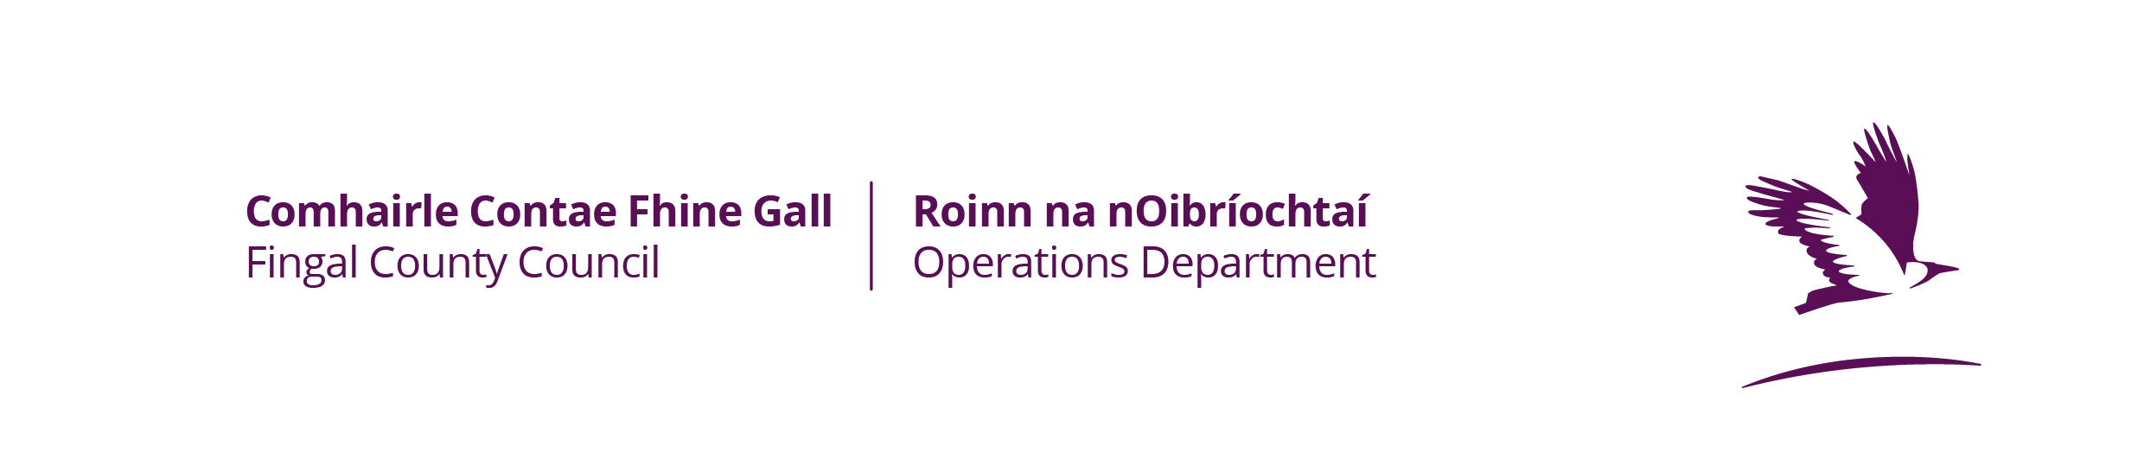

Application for Playing Pitch Season 2023 –2024

No of Council Pitches
Allocated last Season Please also include your membership numbers for the coming 2023/2024 season

Form to be filled in Block Capitals

Name of Club

Please complete this section in full.
Name of Club Officials | Address | Phone
Secretary |  | Mobile  Home/Work
Chairman |  | Mobile  Home/Work
Contact Person |  | Mobile  Home/Work
Contact Email Address: ___________________________________________

Does your Club have a Current Public Liability Insurance policy? Yes/No

Is Fingal County Council specifically indemnified on your policy? Yes/No

Insurers | Policy Start Date | Expiry Date | Policy No

League Affiliation Certificate

Part A – Juvenile Teams (i.e. Teams Under 18 years)

I hereby certify that the ___ teams as listed overleaf belonging to __________________________________ Club have been accepted into the leagues organised by my Association/Board and that all necessary Affiliation Fees have been paid by the Club. The home matches for this club will be fixed for ____________________________________ Park and no other location during the ___________ Season

__________________________ __________________
Signed Title

Apply League Stamp Here

Part B – Senior Teams (i.e. Teams Over 18 years)

I hereby certify that the ___ teams as listed below belonging to __________________________________ Club have been accepted into the leagues organised by my Association/Board and that all necessary Affiliation Fees have been paid by the Club. The home matches for this club will be fixed for _____________________________________ Park and no other location during the ___________ Season

__________________________ __________________
Signed Title

Apply League Stamp Here

Note: Please complete this form for teams playing on Fingal County Council pitches only. Each column must be completed in full. Incomplete or inaccurate application forms will not be accepted. Any subsequent reduction in the number of teams as stated below must be notified to this office.

 | No. of Teams / and Membership Numbers | Code  *see below | League | Playing Day | Playing Times  am/pm | Season From Month | Season to Month
u/8
u/9
u/10
u/11
u/12
u/13
u/14
u/15
u/16
u/17
u/18
Total Juvenile Teams
u/21
Junior
Intermediate
Senior
Total Adult Teams

Codes
Soccer | Gaelic Football | Hurling | Camogie | Rugby | Cricket | Other
S | GF | H | CAM | R | CK | O

Does your Club have Private Pitches  Please give details of location  number of pitches | Yes/No  ___________________________________________  ____________
Pitch Accommodation last Season  (state location) | - Fingal County Council  ________________________________________________  _______________________________________________  - Private Ground __________________________________

For Midweek Fixtures see General Conditions of Letting

CLUB COLOURS: HOME: _____________________________
AWAY: ______________________________

I hereby certify that I have read and accept the Conditions of Pitch Allocation and certify that the information contained within this application is true and I agree that any inaccuracies regarding the information or breach of the conditions may result in the Club having its allocation for all its teams withdrawn for a period of up to one calendar year.

Signature and office of Club Official making application: (please note, all correspondence will be directed to this person)

Signature: ___________________________________ Position Held: ____________________________

Block Capitals _________________________________

Check List: 1. Completed Application Form □
2. Stamped Affiliation Cert □ 3. Letting Fee □ 4. Insurance (with indemnity to Fingal County Council) □
Tick as appropriate

Tá leagan Gaeilge den fhoirm seo ar fail

